Humidity Optional Assignment Answers

1. Determine the following for Point A on the graph on the back of this page:

1. air temperature __70º F__ 2. mixing ratio__6 g/kg__ 3. dew point__45º F__

4. relative humidity __40 %__ 5. saturation mixing ratio __15 g/kg__
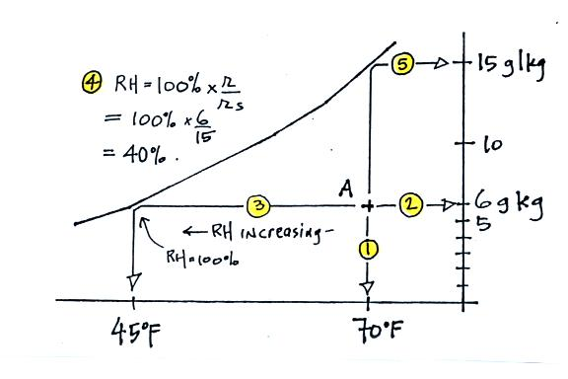

2a. If the air temperature is 70º F and the mixing ratio is 5 g/kg, what is the relative humidity? What is the dew point temperature?
RH = 33%, Td = 40º F (see below)
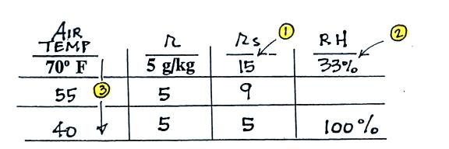

1. Look up r_{S} in table.
2. Compute RH = 100% x r/r_{S} = 100% x 5 g/kg/15 g/kg = 33%
3. cool air until r = r_{S}, RH = 100%. Td is 40º F

2b. Determine the mixing ratio and the dew point temperature when the air temperature is
65º F and the relative humidity is 40%.
r = 5 g/kg, Td = 40º F
In one respect the dew point and the mixing ratio are the same: they both tell you how much water vapor is in the air. Two volumes of air that have the same mixing ratio will have the same dew point and vice versa.

2c. Calculate the relative humidity and the mixing ratio when the air temperature is
65º F and the dew point temperature is 50º F.
r = 7.5 g/kg, RH = 60%
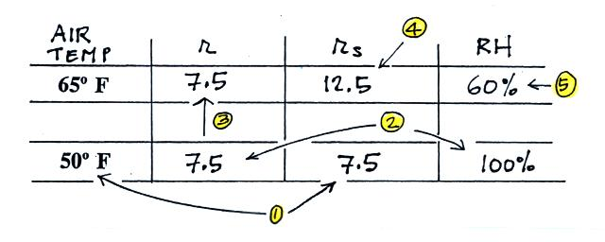

1. Fill in Td, look up r_{S} at the dew point temperature
2. When air with a temperature of 65º F is cooled to the dew point, the relative
humidity becomes 100%. So set RH = 100% for the 50º F air. Set r = r_{S}.
3. The mixing ratio wouldn’t have changed when cooling the air from 65º F to 50º F
(because no water vapor was added or removed). So r must have been equal to
7.5 g/k to begin with.
4. Look up r_{S} for the 65º F air.
5. Compute RH = 100% x r/r_{S} = 100% x 7.5 g/kg/12.5 g/kg = 60%

3a. This is a much easier question than many people realized. 1 kilogram of 70º F air would contain 15 grams of water vapor if the air was saturated (you look up the value of r_{S}, the saturation mixing ratio). If you turn 15 grams of water vapor to water, you’ll have 15 grams of water. There are 5 grams in a teaspoon of water so you would collect
15 grams water/ 5 grams per teaspoon = 3 tsp of water
3b. Since we know the dew point we can readily find the mixing ratio, just like we did in Question 2c. As a matter of fact the air in 2c and in 3b has the same dew point. So the mixing ratio must be the same in both cases
r = 7.5 g/kg

4. Assume that the actual amount of water vapor in the air remains the same during the day. Then ___c___ and ___e___ will remain constant, ___a___ and ___b___ will probably be higher in the afternoon than in the morning, and ___d___ will be higher in the morning than in the afternoon.
a. air temperature b. saturation mixing ratio c. mixing ratio
d. relative humidity e. dew point temperature

The amount of water vapor in the air does not change during the day. The mixing ratio’s job is to tell you how much water vapor is in the air. It isn’t affected by changes in air pressure or air temperature (unless you cool the moist air below the dew point and cause water vapor to condense). So the mixing ratio will remain constant throughout the day. Dew point really does the same job that mixing ratio does. So the dew point won’t change during the day either.

It is generally warmer in the afternoon than it is in the morning. So the air temperature will be higher in the afternoon than in the morning. The value of the saturation mixing ratio depends on the air temperature. Warmer air can hold more water vapor than cold air can. The saturation mixing ratio will also be higher in the afternoon than in the morning.

To calculate relative humidity you divide the mixing ratio by the saturation mixing ratio. Since the mixing ratio doesn’t change and r_{S} is higher in the afternoon than in the morning, the RH is highest in the morning. Another way to answer this question is to ask yourself when are you most likely to see dew, in the morning or the afternoon. In the morning of course. Dew forms when the air cools to the dew point and the relative humidity reaches 100%. The RH is highest (sometime 100%) in the morning when the air is cool.

