NATS 101 Name__________________________________
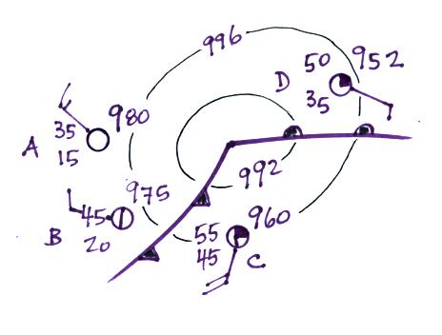
Optional Assignment

1. The coldest air is found at _______
on the surface map at right. The highest
pressure is at _______. Is this a center
of HIGH or LOW pressure, a CYCLONE
or an ANTICYCLONE. The fastest winds
are being reported at _______. A COLD
WARM front is headed toward City D.
The moistest air is found at _______.

2. Clouds absorb _______, reflect _______, and emit _______ radiation. (fill in each blank with UV for ultraviolet, IR for infrared, or VIS for visible).
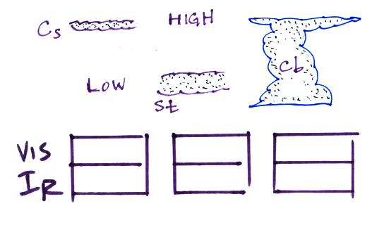
3. Indicate at right whether each cloud would appear W(white) or G(grey) on visible and
infrared satellite photographs.

4. Based on the data at right MONDAY TUESDAY must have Monday Tuesday
been a cloudy day. Have the clouds affected mainly the daily Hi 85 F 90 F
RANGE of temperature or the daily MEAN temperature? Lo 65 F 60 F

5. Delicate streaks of cloud high in the sky would probably be _______, Ci Cs Cc
a middle altitude cloud with little patches of cloud the size of your Ac As Ns
thumbnail would be _______. _______ is a low altitude cloud that Sc St Sc Cb
resembles balls of cotton or perhaps the head of a cauliflower.
A halo is a pretty sure indication of _______. A _______ cloud can produce hail, lightning, and sometimes tornadoes. A lumpy low level layer cloud would be called _______. A patchy appearing high altitude cloud _______. If _______, a middle altitude layer cloud starts to produce rain or snow its name changes to _______. _______ is a low altitude layer cloud.
(fill in each blank with the cloud name abbreviation grouped together above at right. All 10 cloud type names should be used)

6. In air _______ is the least efficient of the energy transport processes listed below. Ocean currents are an example of energy transport by _______. As far as the atmosphere is concerned, the two most important energy transport processes listed below are _______ and _______.
a. convection b. latent heat c. EM radiation d. conduction
7. _______, _______ , _______ & _______are all found at the equator. _______ & _______ are found between the equator and 30º N. _______, _______ & _______ are all found at 30º N.
a. doldrums b. horse latitudes c. trade winds d. low pressure belt
e. high pressure belt f. easterly winds g. intertropical convergence zone
h. cloudy skies i. clear skies

8. You could use the air temperature at right to determine _______. Tair = 85 F
The dew point temperature could be used to determine _______. Td = 55F
The difference between the air temperature and the dew point Tair-Td = 30 F
temperature tells you whether the _______ is high or low.
(fill in each blank with r (mixing ratio), rs (saturation mixing ratio) or RH (relative humidity)
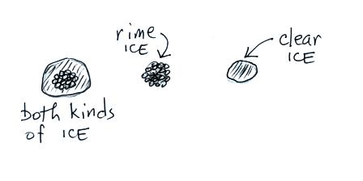
9. Name the 4 (yes four) types of precipitation sketched at right.
(the 4th one is on the far right side of the sketch)

10. The formation of a cloud involves condensation (gas to liquid), freezing (liquid to solid), and deposition (gas to solid). Would cloud formation WARM or COOL the surrounding air.

11. Oceans moderate climate which means COOLER WARMER summer temperatures and COOLER WARMER winter temperatures than would be found at a location at the same latitude and altitude but surrounded by land.

12. You add energy to an object of known mass and measure the temperature change that results.
You could use this information to determine the object’s _______
a. conductivity b. density c. kinetic energy d. latent heat e. specific heat
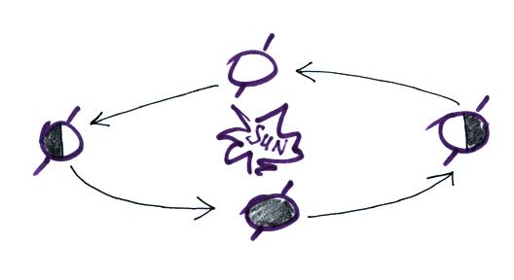

13. With an X indicate the present location of the earth
in its orbit around the sun.

14. Indicate whether following terms pertain to T (thunderstorms or tornadoes) or H (hurricanes)

mesocyclone_______ eye wall _______ storm surge_______ hook echo_______

wall cloud_______ microburst_______ supercell_______ typhoon_______

