Seasons Sample Questions

1. The earth is furthest from the sun in JANUARY JULY.

2. The _______ is on March 20 this year. March 20th will be the first day of spring.
a. solstice b. equinox c. aphelion d. perihelion

3. The moon orbits the earth about once every
a. day b. week c. month d. year

4. On the equinoxes the sun rises in the
a. north b. northeast c. east d. southeast e. south

5. The winter solstice would be found at Point _______ in the figure below.
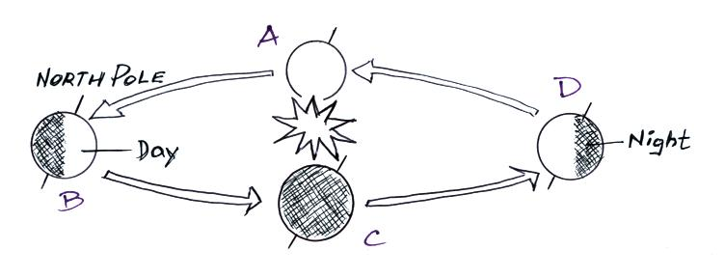

6. Days are greater than 12 hours long in Tucson between
a. the summer and winter solstices
b. the spring and fall equinoxes
c. the summer solstice and the fall equinox
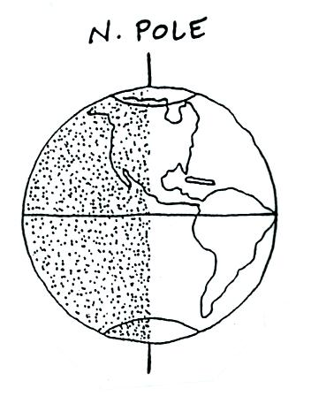
d. all year

7. The earth has the orientation shown in the figure at
right
a. on the summer solstice
b. on the winter solstice
c. on one of the equinoxes
d. never

