Upper Level Charts Pt. 2
Here's a little more in depth look at upper-level charts. You'll find most of the figures below on pps. 115-119 in the photocopied ClassNotes.

Hopefully you still remember the trought (u-shape) and ridge (n-shape) features, the fact that cold air is found under an upper level trough and warm air below a ridge, and that the upper level winds blow parallel to the contour lines and from west to east.
1. By the end of reading you should better understand what the title "850 mb Chart" on the upper level map above refers to.
2. You should also understand what the numbers on the contour lines represent and what their units are. On a surface map contours of pressure, isobars, are normally drawn. That is usually not the case on upper level charts. You'll have a better idea of where the names trough and ridge come from.
3. Note that the values on the contours decrease as you move from the equator toward higher latitude. You should understand why that happens (temperature also decreases as you move toward higher latitude, maybe that is the explanation). You should understand why troughs and ridges are associated with cold and warm air, respectively.

You really only need to remember two things from earlier in the semester (you'll find the figure above at the bottom of p. 115 in the photocopied Classnotes): (1) pressure decreases with increasing altitude, and (2) pressure decreases more rapidly in cold high-density air than it does in warm low density air.
Pressure drops from 1000 mb to 800 mb, a 200 mb change, when moving upward 1500 meters in the cold air. It decreases from 1000 mb to 900 mb, only 100 mb, in the same distance in the warm low density air.

Isobars on constant altitude upper level charts

One way of depicting upper level conditions would be to measure pressure values at some fixed altitude above the ground. This approach is shown above. Pressures range from 800 mb to 900 mb at 1500 meters altitude. The pressure pattern could then be plotted on a constant altitude chart using isobars (figure below). Note the lowest pressures are found in the cold air, higher pressures would be found in the warm air.

That would seem to be a logical way of mapping upper level atmospheric conditions. Unfortunately that isn't how things are done.

Height contours on constant pressure (isobaric) upper level charts
Just to make life difficult for NATS 101 students, meterologists do things differently. Rather than plotting conditions at a constant altitude above the ground, meterologists measure and plot conditions at a particular reference pressure level above the ground.

In the picture above you start at the ground (where the pressure is 1000 mb) and travel upward until you reach 850 mb pressure. You make a note of the altitude at which that occurs. In the cold dense air at the left pressure decreases rapidly so you wouldn't need to go very high, only 1200 meters. In the warm air at right pressure decreases more slowly, you would have to going higher, to 1800 m.
Every point on the sloping surface above has the same pressure, 850 mb. The altitude above the ground is what is changing. You could draw a topographic map of the sloping constant pressure surface by drawing contour lines of altitude or height.

The two kinds of charts (constant altitude or constant pressure) are redrawn below.
The numbers on the contour lines have been left off in order to clearly see that both types of maps have the same overall pattern (they should because they're both depicting the same upper level atmospheric conditions).

In the example above temperature changed smoothly from cold to warm as you move from left to right (west to east).
See if you can figure out what temperature pattern is producing the wavy 850 mb constant pressure surface below.

It shouldn't be too hard if you remember that the 850 mb level will be found at relatively high altitude in the warm air where pressure decreases slowly with increasing altitude. The 850 mb level will be found closer to the ground in cold air where pressure decreases rapidly with increasing altitude. The answer is on the next page.
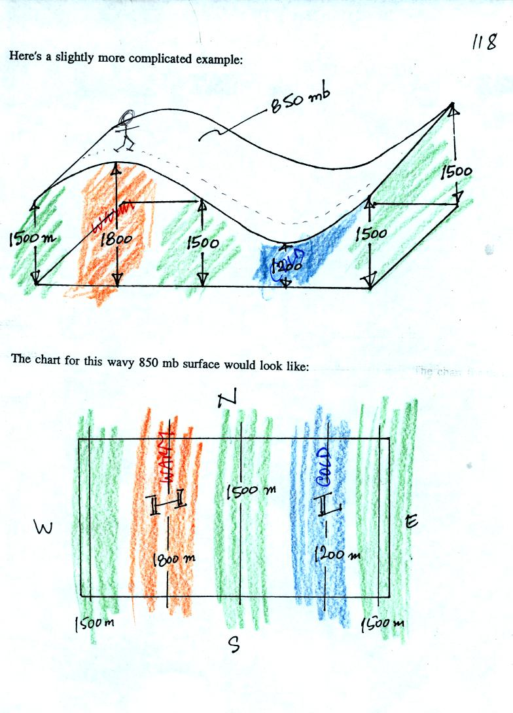

In the next figure we are going to add south to north temperature changes in addition to the west to east temperature gradient.
Here's what the temperature pattern will look like.

Temperature drops as you move from west to east (as it did in the previous pictures) and now it drops as you move from south to north. What will the wavy 850 mb constant pressure surface look like now? The answer is on the next page.

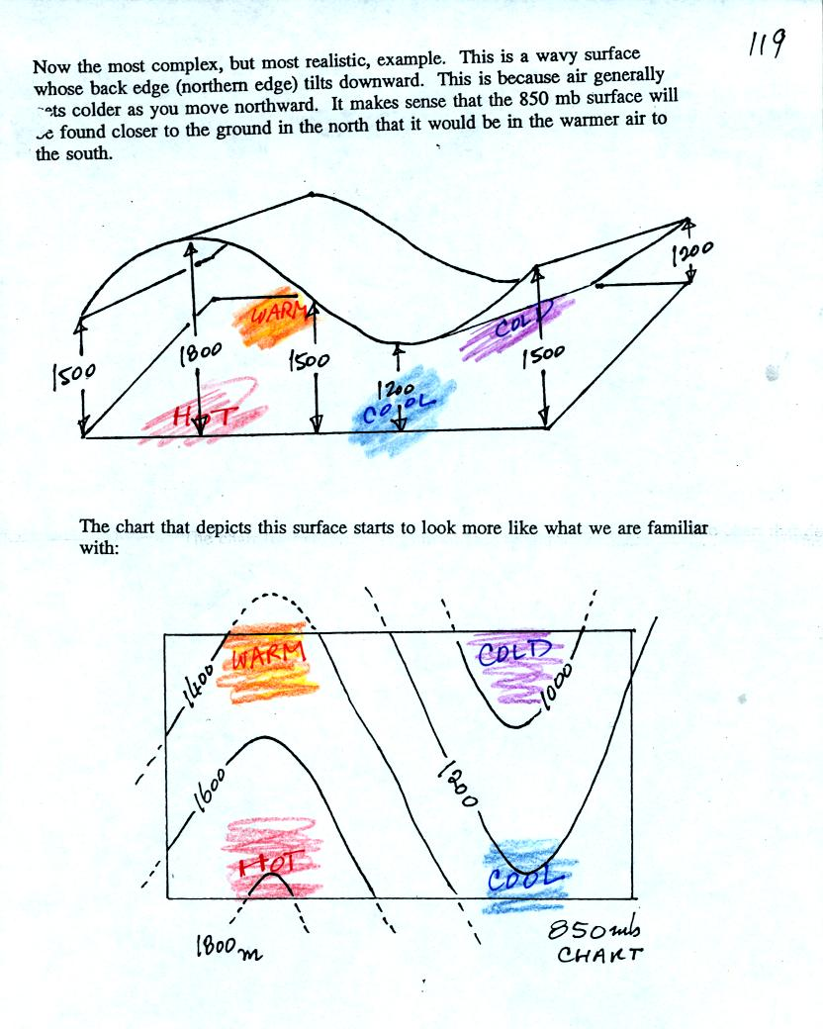

Now let's go back to the figure at the top of p. 115 in the photocopied Classnotes.

1. The title tells you this is a map depicting the 850 mb constant pressure level in the atmosphere.
2. Height contours are drawn on the chart. They show the altitude, in meters, of the 850 mb pressure level at different points on the map.
3. The numbers get smaller as you head north because the air up north is colder. The 850 mb level is closer to the ground.

Here's a figure with some questions to test your understanding of this material.

This is a 500 mb constant pressure chart not an 850 mb chart like in the previous examples.
Is the pressure at Point C greater than, less than, or equal to the pressure at Point D (you can assume that Points C and D are at the same latitude)? How do the pressures at Points A and C compare?
Which of the four points (A, B, C, or D) is found at the lowest altitude above the ground, or are all four points found at the same altitude?
The coldest air would probably be found below which of the four points? Where would the warmest air be found?
What direction would the winds be blowing at Point C?
The answer is on the next page.

1. This is a constant pressure chart. The pressures at Points A, B, C, and D are all the same - 500 mb.
2. Point A is found at the lowest altitude - 5400 meters. Point D is found at the highest altitude - 5640 meters.
3. The coldest air is found below Point A, the warmest air is below Point D.
4. The winds blow parallel to the contours from west to east as shown on the map above. The winds at Point C are blowing from the west.

Finally we will compare upper level charts in the northern and southern hemisphere

The contour values get smaller as you move toward colder air. The cold air is in the north in the northern hemisphere and in the south in the southern hemisphere. The winds blow parallel to the contour lines and from west to east in both hemispheres.

