Experiment Report Format
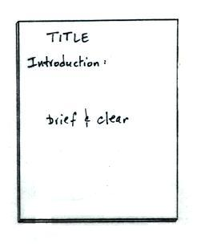
Title (5 pts) Your report should have a descriptive title

Introduction (10 pts) This is perhaps the most difficult
part of the report to write. You must have a good
understanding of the whole experiment to be able to write
a clear and complete introduction.

The introduction should explain in fairly general terms
what kind of measurement you tried to make and how
you made it. Don’t describe the experiment in detail here;
that belongs in the procedure section of your report.

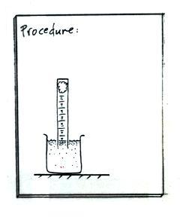
In the oxygen concentration experiment, for example, you
are trying to measure how much oxygen is in the air. Air
is a mixture of several different gases. In your introduction
you should explain in a sentence or two how you were able
to separate the oxygen from the other gases. Air is invisible.
What sort of visible change was there that you could see and measure?

Procedure (10 pts) Here you explain exactly how you
carried out the experiment. Someone unfamiliar with the experiment should be able to perform it using just your
description of the procedure.

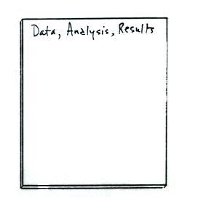
The procedure should be written in a narrative style rather
than a numbered list of steps or instructions. Pictures can be
very helpful and often save a lot of written description.

Data, Analysis, and Results (10-15 pts) Include your original data collection sheet, not a copy. For this experiment you should include a graph of your data. Use graph paper, make the graph large, and label the axes. You should include an example of all but the simplest calculations. Be sure to include units where appropriate.

