Experiment #1 – Instructions
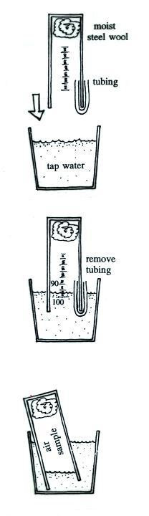
Materials:
100 mL graduated cylinder (caution – glass)
small piece of steel wool
small length of flexible tubing
plastic drinking glass
paperclip

Starting and Conducting the Experiment:
Thoroughly soak the steel wool in tap water in a small
container of some kind. Use a pencil to be sure the steel wool
is completely submerged and does not contain any trapped air
bubbles. After a minute or so remove the steel wool and blot
off any excess water. The steel wool should be damp or moist
but not dripping wet.

Fill the drinking glass about ¾ full with cold tap water.
Push the moist piece of steel wool to the bottom of the graduated
cylinder (the steel wool should remain in place when the
cylinder is turned upside down). Insert about half the length of
the flexible tubing into the cylinder; bend and hold the other end
of the tubing against the outside of the cylinder. While keeping
the ends of the tubing out of the water, invert the cylinder and
slowly over the open end into the water in the glass. The tubing
will allow water to rise up inside the cylinder so that its level
can be read on the cylinder scale. Once the water has reached a
point between the 90 and 100 mL readings on the cylinder,
carefully pull out the tubing. The air sample is now sealed off
from the rest of the atmosphere.

Make a note of the time (to the nearest half hour) and
note the level of the water in the cylinder. Lower the cylinder until
the open end is resting on the bottom of the plastic cup (be sure
that air doesn’t escape from the cylinder).

With time, oxygen in the air trapped in the cylinder will react with the steel wool to form rust. As this occurs, you should find that the volume of air in the cylinder decreases. You will need to periodically measure the time and the volume of the air in the cylinder (you may need to raise the cylinder slightly so that the water level can be seen and read). You should check the water level fairly frequently at the beginning of the experiment. Continue the experiment until the air sample volume stops changing (this may take several days).

