Data Collection

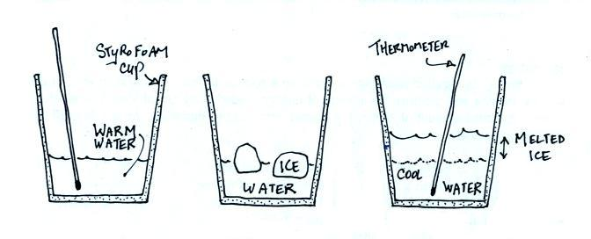
mass ice melted = mass_{final} - mass_{initial}
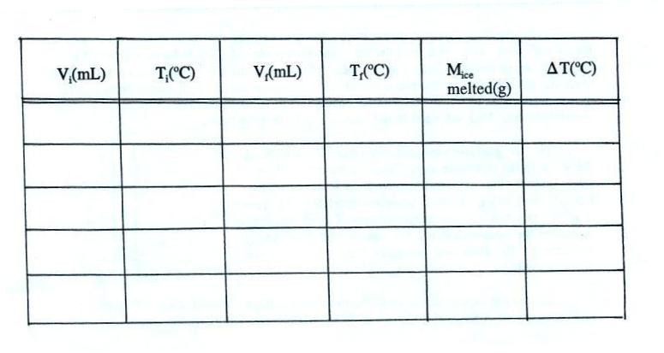
ΔT = T_{initial} - T_{final}

