Latent Heat of Fusion of Ice Experiment

Materials:
100 mL graduated cylinder (caution – glass)
12 oz or 16 ox Styrofoam cup
thermometer and ice (to be supplied by the student)

Experiment:
Energy is required to change water from a solid to a liquid, i.e. to melt ice. In this experiment you will measure the amount of energy needed per gram of ice. You must remove the same amount of energy per gram if you want to turn water from a liquid into a solid (freeze water).

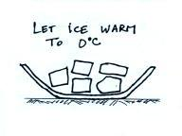
Before you begin the experiment you should obtain some ice.
You will need a few ice cubes or about half a cup of crushed ice.
Put the ice in a bowl and let it sit at room temperature until you notice
that it is starting to melt. This will probably take 15 or 20 minutes.
In the freezer ice is kept at a temperature well below freezing. We
need to allow the ice to sit outside the freezer long enough that it warms
up to 0º C. The ice can’t get warmer than 0º C, once it gets to 0º C it
will start to melt.

Add 200 to 250 mL of warm or hot tap water (40º C or less) to the Styrofoam cup. This warm water will be the source of the energy used to melt the ice. We keep the warm water in a Styrofoam cup so that it doesn’t lose energy to the surroundings. Keep a record of the volume of water added to the cup. Measure and record the temperature of the warm water.

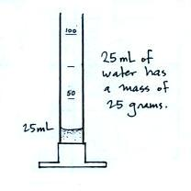
Add one or two ice cubes (or about ¼ cup of crushed ice) to the warm water and stir gently with the thermometer until the ice is completely melted. Try to be sure you just add ice to the warm water and that you don’t also add water in the bowl from ice that has melted. Once the ice is melted measure and record the water temperature. If the water temperatures drops to near 0º C or if you are unable to quickly melt all of the ice, you will need to repeat the experiment. You will need to use more water, less ice, or both.

Use the graduated cylinder to measure the volume of the water
in the Styrofoam cup. This new volume will be larger than the initial
volume because ti contains the water from the melt ice. Because
water has a density of 1 g/cm³ (1 g/mL) you can use your measurement
of water volume to determine the mass of water at the start and finish
of the experiment. The differences in masses is the mass of the ice
that was melted.

Repeat the experiment at least one more time using a different amount of water, a different amount of ice, and perhaps a different initial water temperature.

