Typical Development of a “Mixed Layer” Above the Ground on a Sunny Day

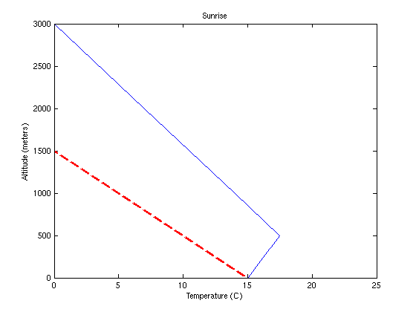
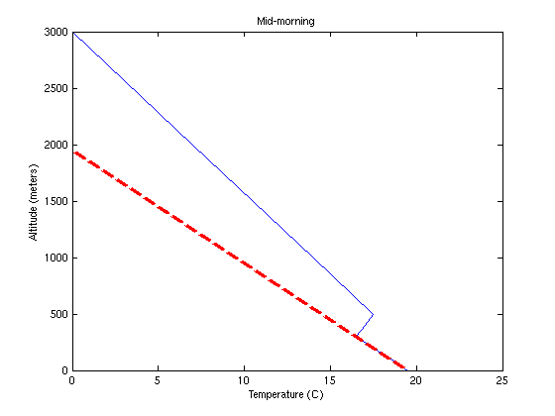
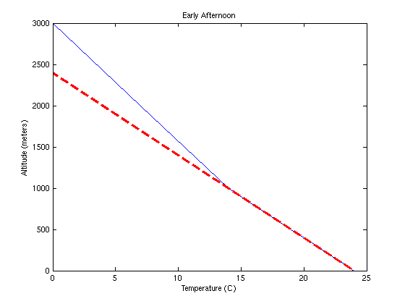
The figures above represent the way that the air temperature typically changes during a day when the sun is shining. On each plot, the solid line represents the temperature structure of the troposphere from the ground surface upward to 3000 meters above the ground, while the dashed line represents the temperature within an air parcel lifted upward from the surface.
At sunrise, it is common for a temperature inversion to exist just above the ground surface as shown in the top plot. As the sun begins to heat the ground, parcels of air in contact with “hot spots” on the ground (small areas that better absorb radiation from the sun and thus get warmer than adjacent areas of the ground) become warmer than the surrounding air (at the same altitude) and begin to rise. However, the parcels do not rise up very high at first because they quickly become colder than the air surrounding the parcel. For this reason, we say inversion layers are stable layers. One consequence of this is that early in the morning, air is not able to mix upward and pollution, like vehicle exhaust, is “trapped” just above the ground. In big cities, this pollution can accumulate to dangerous levels during the morning rush hour.
With continued heat transfer from the ground to the air, the rising parcels begin to transfer energy into the atmosphere from the bottom up (dry convection). This begins to erode the inversion layer as seen in the mid-morning plot. Surface parcels in contact with “hot spots” are able to rise to 300 meters before becoming colder than the surrounding air. Thus, at mid-morning, the mixed layer is about 300 meters deep.
By early afternoon, the mixed layer is now 1000 meters deep in this example. Surface parcels warmed by contact with the ground can now rise 1000 meters before becoming colder than the surrounding air. If skies remain sunny, the depth of the mixed layer will often grow until late afternoon. If the mixed layer grows upward to the point where rising parcels reach their saturation level, clouds will form. If the rising parcels reach an unstable layer, then thunderstorms are possible. This explains why thunderstorms that are initiated by surface heating and free convection are most common in the late afternoon.

