http://www.mpi-hd.mpg.de/hfm/CosmicRay/Showers.html
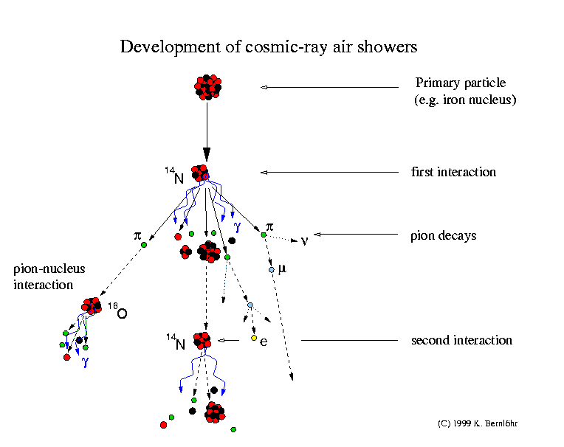

Cosmic-ray air showers

Cosmic rays
The earth is hit by elementary particles and atomic nuclei of very large energies. Most of them are protons (hydrogen nuclei) and all sorts of nuclei up to uranium (although anything heavier than nickel is very, very rare). Those are usually meant when talking about cosmic rays. Other energetic particles in the cosmos are mainly electrons and positrons, as well as gamma-rays and neutrinos.

Interactions and particle production
The cosmic rays will hardly ever hit the ground but will collide (interact) with a nucleus of the air, usually several ten kilometers high. In such collisions, many new particles are usually created and the colliding nuclei evaporate to a large extent. Most of the new particles are pi-mesons (pions). Neutral pions very quickly decay, usually into two gamma-rays. Charged pions also decay but after a longer time. Therefore, some of the pions may collide with yet another nucleus of the air before decaying, which would be into a muon and a neutrino. The fragments of the incoming nucleus also interact again, also producing new particles.
The gamma-rays from the neutral pions may also create new particles, an electron and a positron, by the pair-creation process. Electrons and positrons in turn may produce more gamma-rays by the bremsstrahlung mechanism.

Shower development
The number of particles starts to increase rapidly as this shower or cascade of particles moves downwards in the atmosphere. On their way and in each interaction the particles loose energy, however, and eventually will not be able to create new particles. After some point, the shower maximum, more particles are stopped than created and the number of shower particles declines. Only a small fraction of the particles usually comes down to the ground. How many actually come down depends on the energy and type of the incident cosmic ray and the ground altitude (sea or mountain level). Actual numbers are subject to large fluctuations.
In fact, from most cosmic rays nothing comes down at all. Because the earth is hit by so many cosmic rays, an area of the size of a hand is still hit by about one particle per second. These secondary cosmic rays constitute about one third of the natural radioactivity.
When a primary cosmic ray produces many secondary particles, we call this an air shower. When many thousand (sometimes millions or even billions) of particles arrive at ground level, perhaps on a mountain, this is called an extensive air shower (EAS). Most of these particles will arrive within some hundred meters from the axis of motion of the original particle, now the shower axis. But some particles can be found even kilometers away. Along the axis, most particles can be found in a kind of disk only a few meters thick and moving almost at the speed of light. This disk is slightly bent, with particles far from the axis coming later. The spread or thickness of the disk also increases with distance from the axis.

Shower detection
Extensive air showers with many particles arriving on the ground can be detected with different kinds of particle detectors. In the air the particles may also emit light by two different processes: Cherenkov light almost along the shower axis and fluorescence light in all directions.

Other introductory material found on the net (HTML format):
Cosmic Rays by Richard Mewaldt
Cosmic Rays by James Schombert
Further reading found on the net (Postscript or PDF format):
Particle Data Group: review of cosmic rays
Introduction to high energy cosmic ray physics
Cosmic Ray Spectrum and Composition: Ground Observations

This page was written by Konrad Bernlöhr.

