ATMO/ECE 489/589 Final Exam
May 9, 2011

Everyone should answer Question #1.
ATMO/ECE 489 students should then answer any 3 of the remaining 6 questions
ATMO/ECE 589 students should then answer any 4 of the remaining 6 questions

1. Answer any 3 of the following questions. If you have time and are so inclined you can answer a 4th question.
(a) Interpret or explain how you might use the two E field soundings sketched below to determine the distribution of charge inside a cloud. What sort of vertical cloud charge distribution would each imply? Which sounding would indicate a cloud with an “inverted” charge distribution?
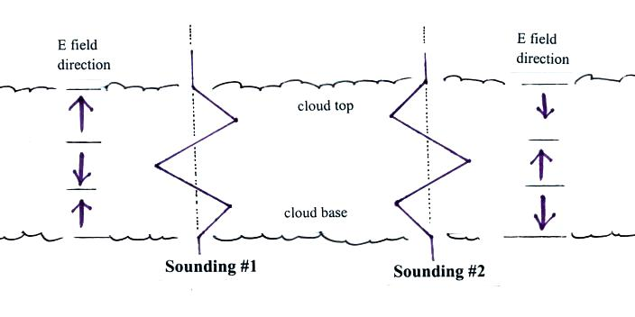

(b) Explain or define the term striking distance. What implications does it have in the design of lightning protection for a building. Attempts have been made to relate the striking distance to the peak return stroke current. Why might a return stroke with a low peak current present more of a hazard to a building than a return stroke with large peak current?
(c) Sketch or design a basic lightning rod/down conductor/grounding system like you might use to protect a small house.
(d) Is there a topic that we covered this semester that you found interesting enough to research further on your own. If so what was it and what did your learn?
(e) We discussed “crowbar” devices and “clamping” devices and showed how they can be used to protect sensitive electronics from lightning transients. Give an example of each type of device and show, in a simple circuit diagram, how they might be used to protect the input to an electronics system of some kind.
(f) The transmission line model expression is widely used to estimate lightning peak current and peak current derivative values from remote radiation field measurements. What is the transmission line model relation between peak return stroke current and peak electric radiation field? What assumptions were made when deriving this expression and what assumptions are made when it is used?

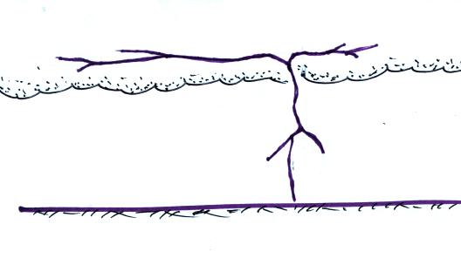
(g) Under what circumstances might using
the time delay between a flash of lightning
and the arrival of the thunder lead you to
underestimate the distance to the lightning
strike point. The figure at right might suggest
something.
(h) The satellite sensors that we discussed in class are able to detect and locate lightning optical signals at night and during the day. Explain how these satellite sensors are able to separate the relatively weak lightning emissions from the much brighter reflected sunlight background signal.

2. Given a fair weather electric field of 200 V/m and a conductivity of 1.5 x 10⁻¹⁴ mhos/m at the ground.

(a) Determine the total resistance, in ohms, of the bottom 100 m of the earth’s atmosphere. You may assume that the electric field and the conductivity are constant in this 100 m thick layer.
(b) Consider the ground and the layer at 100 m altitude to be two electrodes of a spherical capacitor (the ground is negatively charged and positive space charge is found in the air between the ground and 100 m altitude). Derive an expression for the capacitance between the ground and the layer at 100 m.
(c) Show that the discharge time constant RC, where R is the resistance from (a) and C the capacitance from (b), is λ/ε_{o} .

3. At sea level altitude, an electric field strength of about 3 x 10⁶ V/m is needed to breakdown air. Once a discharge is initiated, however, it will propagate in fields that are substantially weaker (300 kV/m, for example, in the case of a positive polarity streamer)
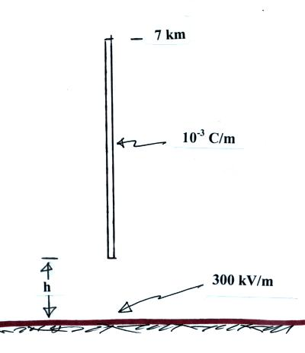

Compute the field at the ground directly below
a vertical stepped leader channel that extends
from a height 7 km above the ground down to
a height h above the ground. How close to the
ground would be bottom of the leader channel
need to be in order to produce a field of 300 kV/m
at the ground? You can assume negative
charge is distributed uniformly along the length
of the leader channel and that the line charge
density, λ, is 10⁻³ C/m.

.
4. Analyses of 5 years of data obtained with the Optical Transient Detector (a satellite based sensor used to detect and locate lightning) has provided a new estimate of global lightning flash frequency of 44 flashes/second. This is a little less than half the 100 flashes/second value long thought to be true.

Translate the 44 flashes/second value into a global average lightning strike density (strikes to ground per square kilometer per year). State/justify any assumptions that you make.

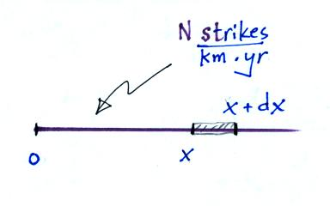
5. On most exams of mine I ask a question that I’m not
sure I know the answer to. Here’s this year’s version.
Assume that there are N strikes per kilometer per year
to a long power line. What is the probability that the
nearest strike is between x and x+dx. Basically you
are being asked to derive a 1-dimensional version of
the nearest neighbor distribution. You can assume
that the point of interest (labeled 0 in the figure at
right is at one end of the line).

6a. What parameters of the return stroke current waveform are responsible for producing high voltages on a grounded down conductor connected to a lightning rod.
6b. Using typical values for these current parameters and reasonable values of the grounding resistance and down conductor inductance estimate the amplitude of the voltages that a lightning strike might produce.

7. The sketch below illustrates some of the paths that signals from a distant lightning return stroke could follow between the source and a receiving antenna located 100s of kilometers away. Radiation can propagate directly to the antenna along the ground; this is the “ground wave.” Radiation initially directed upward can also arrive at the antenna after undergoing one or more reflections between the ground and a conducting layer in the lower ionosphere.

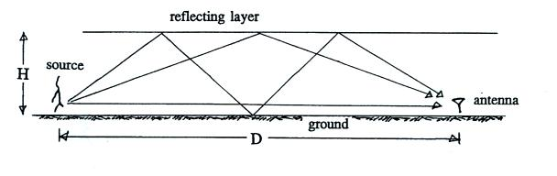

An actual recording of a distant return stroke electric field waveform is shown below. This signal was recorded at Gainesville, FL, and was produced by a return stroke that occurred approximately 900 km to the ENE. The ground wave signal as well as the first and second “sky wave” signals (from the one- and multi-reflection paths in the sketch above) are identified. Use these data to estimate, H, the effective height of the reflecting layer in the ionosphere (you may assume the signal is a point source located at ground level).

