ATMO/ECE 489/589 Final Exam
May 6, 2013

Please answer Question #1 (25 pts) and any 3 of the remaining questions (20 pts each)

1. Answer any 5 of the following questions.
(a) A cloud-to-ground lightning discharge has a duration that is usually less than 1 second. Why does the thunder last much longer than that?
(b) Summarize as completely as you can the physical characteristics of the first return stroke in a negative cloud-to-ground discharge.
(c) Briefly explain how satellite detectors are able to detect lightning optical signals during the day against the very bright background of sunlight being reflected from the cloud top.
(d) Explain why a series of lightning rods installed on the roof of a building might adequately protect against high current amplitude but not low current amplitude return strokes.
(e) Why would 2 down conductors in the lightning protection system sketched below be preferable to just a single down conductor?
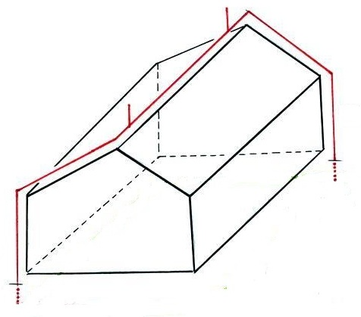

(f) The transmission line model expression is widely used to infer return stroke peak current and current derivative values from remote measurements of electric and magnetic radiation fields. What assumptions are made in deriving the transmission line model equation?
(g) There is pretty convincing evidence that lightning occurs on Jupiter. What similarities and differences are there in the clouds thought to produce lightning on the earth and on Jupiter?
(h) What do you think is the simplest and most effective way of protecting sensitive home electronics from damage during a lightning storm?

2(a) Determine the maximum charge that could be stored on a spherical, 1/4 inch diameter, graupel particle assuming the breakdown electric field is 2 x 10⁶ V/m. You can neglect any effects of the ambient field and assume that the charge is uniformly distributed on the graupel particle. (there are 2.54 cm in 1 inch)

(b) Use your result in part (a) to determine the ambient field that would be needed to produce an upward force on the graupel particle that would just balance the downward gravitational force on the particle. You can assume that there are no drag forces acting on the graupel particle. The gravitational acceleration, g, has a value of 9.8 m/s and you can assume the graupel is composed of rime ice with a density of 0.8 g/cm³.

3 Determine the strength of the electric field at the ground directly under a stepped leader channel extending from 6 km to a point 100 meters above the ground. You can assume that charge is uniformly distributed along the leader channel and that the line charge density is 1 x 10⁻³ C/m. Assume also that the ground is flat and a perfect conductor.

4. For me one of the interesting parts of Dr. Cummins’ first lecture was where he gave a possible explanation for the chaotic activity that follows positive cloud-to-ground discharges in the Central Plains (you may remember my comment “I have no idea what is going on here” when we saw some of that on one of the high-speed videos). As I understand it, a positive CG neutralizes the positive charge in the anvil leaving negative charge in the screening layers at the top and bottom surfaces of the anvil. This sudden increase in the field causes upward propagating positively charged leader discharges to develop off the tops of tall TV transmission towers that are common in the region.

That’s the reason for this question - to make an estimate of how much of an intensification of the field this might produce. Marshall, Rust, Winn, and Gilbert (1989) have made electric field soundings through anvil clouds and found negatively charged screening layers at the top and bottom surface of the anvil cloud ([a] and [c] in the table below], a layer of positive charge in the interior ( [b] in the table), and one or two layers of zero charge.

Data from a sounding of an anvil in Oklahoma are summarized in the table below. Note the last column, ρ Δz, is essentially a surface charge density, σ.
ρ (nC/m³) Δz (m) Zmin (km) T (ºC) Zmax (km) ρ Δz (nC/m²)
cloud top -630 [a]
0 7.5 -22 0
+2.4 600 6.9 -19 7.5 +1440 [b]
0 1200 5.7 -12 6.9 0
-2.7 300 5.4 -10 5.7 -810 [c]

(a) Use the data above to determine the strength of the electric field below the anvil cloud when all three charge layers are present. You can assume the anvil cloud is of infinite horizontal extent and can ignore any effects of the ground below.

(b) How much larger will the electric field become if a positive cloud to ground discharge completely removes all of the positive charge in layer [b]?

5. Using results from his experimental test of the transmission line model Willett et al. (1989) gives what he considers to be the best formula for estimating peak currents in natural lightning return strokes from remote measurements of peak fields. That formula is

I_{P} = - 0.039 D E_{P} – 2700

D is the range to the discharge in meters, I_{P} is the peak current in Amperes, and E_{P} in the peak electric field in volts/meter. E_{P} will be negative and I_{P} positive for a return stroke lowering negative charge to ground.

Rakov et al. (1992) argue that because the equation above comes from a regression of E on I it is not the best expression to use to determine peak I values from measurements of peak E. Rather a regression of I on E should be used. The formula obtained by the regression of I on E determined using the same data as those of Willett et al. (1989) is

I_{P} = - 0.037 D E_{P} + 1.5

NB: Here I_{P} is the peak current in kA and negative, E_{P} is positive and in V/m,
and D is in km.

(a) What is the value of the return stroke velocity assumed or implied in each expression?

(b) Use both expressions to compute I_{P} for a 1st return stroke peak field E_{P} = 7.5V/m at 100 km range.

6. The peak values of B_{EW} and B_{NS} measured using two orthogonal loop antennas can be used to determine a bearing angle to the lightning discharge producing the fields. If bearing angles are available from antennas at two or more separate locations triangulation can determine the location of the discharge.

However, as the figure below shows, small bearing angle errors can lead to uncertain locations when the discharge is on or near the baseline connecting two stations.
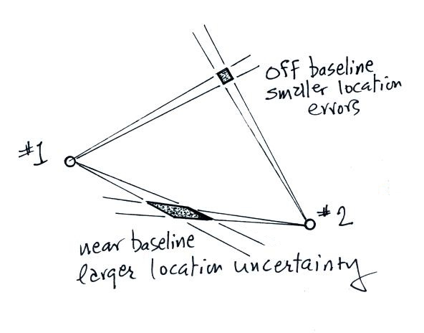

Measuring the time of arrival of the signals at each antenna can be used to improve location accuracy. Can you think of another way of using the measurements of B_{EW} and B_{NS} at each of the two stations to reduce the location errors for discharges on or near the baseline? You can assume that, at the time of peak field, the magnetic fields at both stations are 100% radiation field.

