ATMO/ECE 489/589 Spring 2013
Homework #4 due Tue., Feb. 26

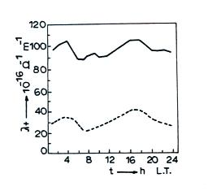
1. (10 pts) On April 26, 1986, the Chernobyl nuclear reactor
injected a plume of radioactive materials [cesium (¹³⁷Cs), iodine (¹³¹I), and ruthenium (¹⁰³Ru)] into the lower atmosphere that was subsequently carried to many locations in Europe within a few days. The plume arrived over Greece on May 3. The figure at right compares the
long term average daily variation of positive
conductivity (λ₊) observed in May (dotted line) with
enhanced positive conductivity observed in May 1986
(solid line). [see Retalis, D. & A. Pitta, “Effects on
Electrical Parameters at Athens Greece by
Radioactive Fallout from a Nuclear Power Plant
Accident”, in the class articles folder]

(a) How would you expect the higher conductivity observed in May 1986 to have changed values of the fair weather electric field at the ground?

(b) Use the positive conductivity values in the figure above to determine the positive small ion concentrations, n₊, before and after the arrival of the radioactive plume.

(c) Assuming steady state conditions and neglecting small ion to particle attachment, determine the small ion production rate, q, before and after the arrival of the plume.

You may use values given for sea level altitude on the “Summary of Electrical Parameters vs Altitude” handout for any constants that you might need (see the Thu., Feb. 14 online notes)

2. (10 pts) An electric dipole consists of two charges of equal magnitude, q, but opposite polarities that are separated by a small distance, L. If such a dipole is located a distance, r, from a point charge, +Q, as shown below, show that the attractive force between Q and the dipole varies as the inverse third power of r. (assume L<< r)
