ATMO/ECE 489/589 Spring 2013
Homework #5 due Tue., Apr. 2

1. The first stroke from a severe (worst case) lightning current waveform used in lightning testing is shown below (a test waveform would normally include several subsequent strokes).

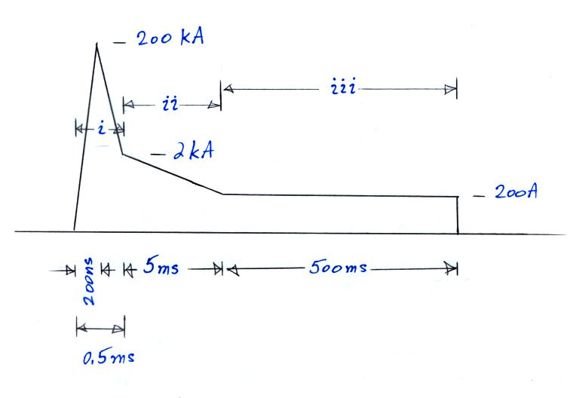

(a) Determine the peak dI/dt value (you can ignore the discontinuity at the end of the waveform)
(b) Determine the charge transferred in intervals (i), (ii), and (iii). Which interval transfers the most charge?
(c) Compute the “action integral” for intervals (i), (ii), and (iii). Which interval makes the largest contribution to the action integral.
(d) Determine the total energy delivered by the entire waveform to a resistive load of 10 ohms.

2. Watch the Franklin Lecture "Lightning and Climate" presented by Earle Williams at the Fall 2012 meeting of the American Geophysical Union in San Francisco. The lecture is available at.
http://fallmeeting.agu.org/2012/events/franklin-lecture-ae31a-lightning-and-climate-video-on-demand/
Put together a short summary of the lecture. I would like to put together an accompanying set of notes and would be interested in knowing what you found most interesting and where you think some additional background information might be helpful.

