ATMO/ECE 489/589
Homework #7 (due Tue., Apr. 23)

1. The sketch below illustrates some of the paths that signals from a distant lightning return stroke could follow between the source and a receiving antenna located 100s of kilometers away. Radiation can progagate directly to the antenna along the ground; this is the "ground wave." Radiation initially directed upward can also arrive at the antenna after undergoing one or more reflections between the ground and a conducting layer in the lower ionosphere.
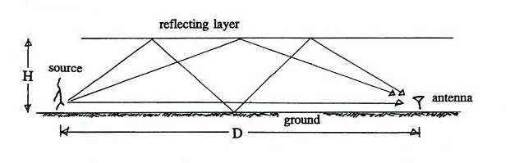

An actual recording of a distant return stroke electric field waveform is shown below. This signal was recorded at Gainesville, Florida, and was produced by a return stroke that occurred approximately 900 km to the ENE. The ground wave signal as well as the first and second "sky wave" signals (from the one- and multi-hop paths in the sketch above) are identified. Use these data to estimate, H, the effective height of the reflecting layer in the ionosphere (you may assume that the signal source is essentially at ground level).
