Vector Differential Operators

Rectangular (Cartesian) coordinates
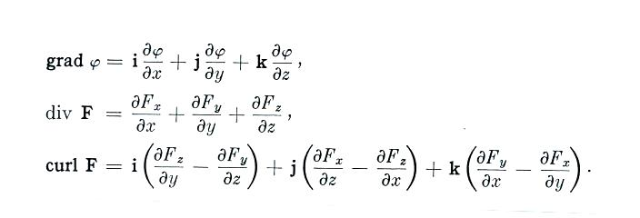

Cylindrical coordinates
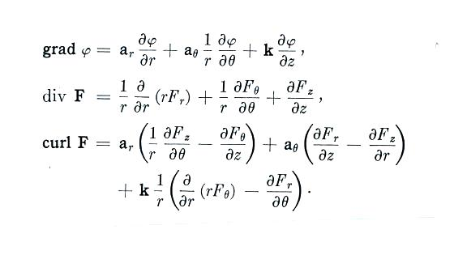

Spherical coordinates
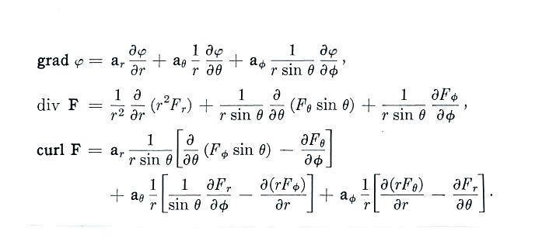

Laplacian (from top to bottom: Cartesian, cylindrical, and spherical coordinates)
