ATMO/ECE 489/589 Midterm Exam
March 5, 2013

Everyone should answer Question #1.
Then answer any 4 of the remaining 6 questions (please start each problem on a new sheet of paper)
Allow about 15 minutes per question

1. (20 pts) Answer any four of the following questions.
(a) What is the basis for assuming that the current density J = J_{z} is constant with altitude?
(b) Briefly define and give an example of the triboelectric effect.
(c) Briefly describe and explain the significance of Franklin’s sentry box experiment.
(d) What is graupel? Where and how does it form?
(e) The main negative charge layer in thunderstorms is almost always found between -10º and -30º C regardless of storm location and time of year. Why is that? Under what conditions can the main body of negative charge be found elsewhere in the thundercloud?
(f) Why might you expect to find electrical charge on the top and bottom surface of a cloud layer during fair weather?
(g) Estimate the power dissipated by the global fair weather electric current.
(h) Why might it be advantageous to connect a flat plate “fast” or “slow” electric field antenna to an active integrator rather than a passive integrator?

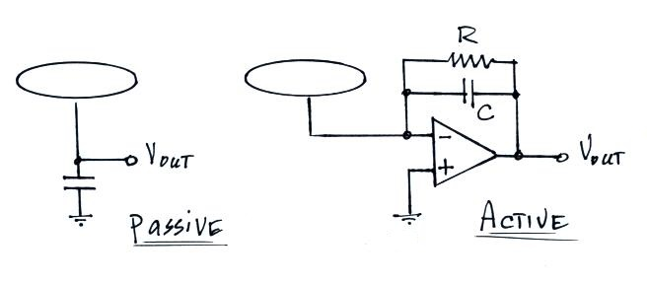

2. (15 pts) Compute the field changes, ΔE, at 5 km range, produced by both a cloud-to-ground (CG) discharge and an intracloud (IC) discharge. You can assume the CG discharge neutralizes -25 C at an altitude of 6 km above ground level and the IC discharge neutralizes -25 C at 6 km altitude and +25 C of charge at 9 km altitude.

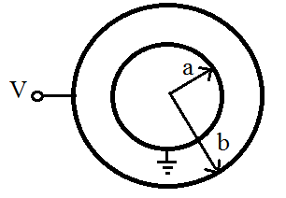
3. (15 pts) Show that the capacitance
of the spherical capacitor sketched at right is

C = 4πε_{o} (ab)/(b-a)

(comment: we did a similar calculation in the lecture about conductivity meters and ion counters)

4. (15 pts) Compute the electric field, E, everywhere above, inside, and below a 500 m thick cloud of infinite horizontal extent. You can assume a uniform cloud volume space charge density of +1 nC/m³.

5. (15 pts) Determine the steady state small ion concentration, n, for “clean” air (Z = 500 particles/cm³) and “dirty” air (Z = 5000 particles/cm³). You can assume

a small ion recombination coefficient α = 1.4 x 10⁻⁶ cm³/sec
a small ion to particle attachment coefficient β = 2 x 10⁻⁶ cm³/sec
an ion pair production rate q = 10 ip/(cm³ sec)

6. (15 pts) Given a fair weather electrical field of 200 V/m and an atmospheric conductivity of 1.5 x 10⁻¹⁴ mhos/m, calculate the total resistance of the bottom 100 m of the earth’s atmosphere. You can assume that E and λ remain constant in the layer.

7. (15 pts) Two electric field antennas are shown in the figure below. One is a flat circular plate (radius = a) that is positioned flush with but electrically isolated from the surrounding ground. The other is a spherical antenna (radius = a) that is positioned above the ground. The upper and lower hemispheres of the sphere are insulated from each other.

Determine the effective gain or collection area of the spherical antenna. (hint: compare the total charge induced on the flat plate with that induced on the upper hemisphere of the spherical antenna when exposed to a downward-pointing electric field, E_{o}).
