ATMO/ECE 489/589 Homework 5 Spring 2007

1.* An electric dipole consists of two equal but opposite polarity charges separated by a small distance, l (see sketch), and the “dipole moment” of this charge configuration is defined to be . If a dipole is located a distance from a point charge, Q, as shown, show that (and explain physically why) the attractive force between Q and the dipole varies as the inverse third power of r.
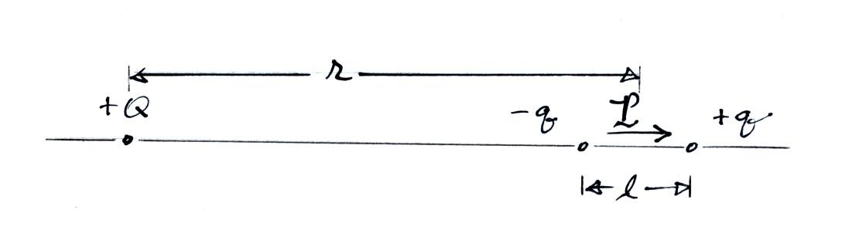

2. A recent measurement of the vertical electric field under a thunderstorm is given below. Assuming that this profile is steady with time and that the air conductivity at ground level is 3 x 10⁻¹⁴ mho/m (or S/m), (a) estimate the vertical electric current density, J_{E} , at an altitude of 500 m and (b) estimate the magnitude and polarity of the average space charge density that is present between the surface and 500 m.
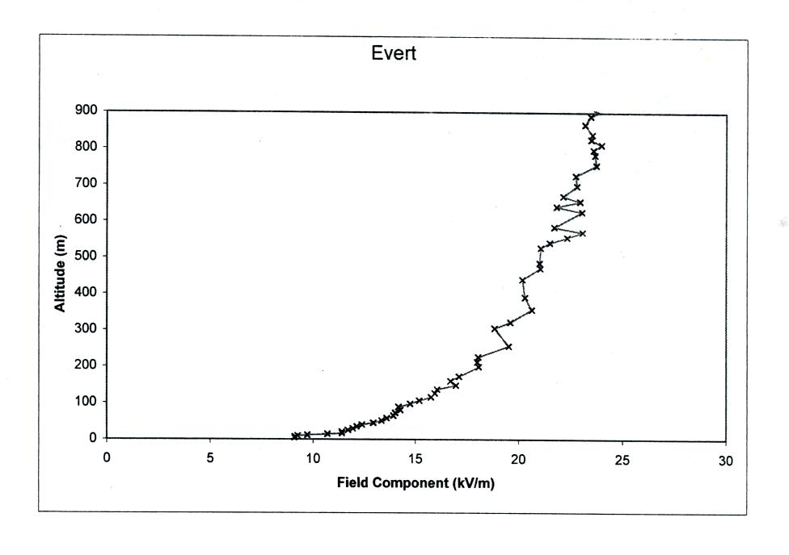
*ATMO/ECE 589. Extra credit for ATMO/ECE 489.

