ATMO 170A1 Optional Assignment Name_________Answers______________
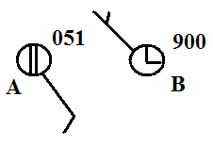
1. Decode the pressure data shown at right and.
determine whether CITY A or CITY B has
the highest sea level pressure value?
You need to add a 9 or 10 in front of the plotted pressure
data and also a decimal point. So for City A the pressure
is either 905.1 mb or 1005.1 mb. You pick the value that is closest to 1000 mb (average sea level pressure). The pressure at City A is 1005.1 mb and 990.0 mb at City B.

2. The atmosphere is split into layers (troposphere, stratosphere, mesosphere, etc.) according to how ___d___ changes with altitude.
a. composition b. density c. pressure d. temperature
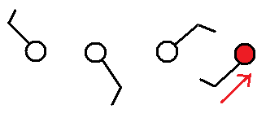

3. Circle the figure at right that shows winds
blowing from the southwest.

4. Would the 5 pm MST weather observations in Tucson be plotted on the 00Z 05Z 12Z or 17Z surface weather map?
First change 5:00 pm MST to the 24 hour clock by adding 12 hours
5:00 pm MST = 17:00 MST
Then add the 7 hour time zone difference (7 hours later in Greenwich at 0 longitude)
17:00 + 7:00 = 24:00 Z = 00 Z
5:01 pm in Tucson on a Tuesday would be 12:01 am on Wednesday in London.

5. Before being plotted on a surface weather map the measured station pressure must be corrected for
a. altitude b. latitude c. temperature d. time of day

6. Show at right how the following weather observations would be plotted using the station model notation.
temperature = 75º F cloud cover = 5/8
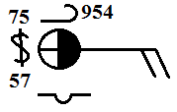
pressure = 995.4 mb dew point = 57º F
wind direction & speed = east at 20 knots
low clouds = stratocumulus clouds
high altitude clouds = filaments of cirrus clouds
present weather = dust or sand raised by wind
at the time of observation

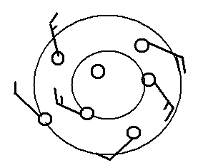
7. The top of an average thunderstorm would be around __10___ kilometers (about 30,000 ft) tall (fill in the blank with 1 10 100 or 1000)

8. Does the figure at right show winds blowing in a
CLOCKWISE or COUNTERCLOCKWISE
direction? Are the winds CONVERGING or
DIVERGING? Does the figure show a surface
center of HIGH or LOW pressure.

9. Which of the following would not cause rising air motions?
a. low pressure center b. high pressure center c. cold front d. warm front

10 The term cyclone is just another name for a center of HIGH LOW pressure.

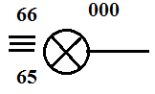
11. Use the weather data plotted at right to fill in the blanks
below (include the correct units, some of the information
requested below may be plotted in the figure at right)

temperature ____66º F____ pressure ___1000.0 mb_____

altitude _not given____ wind direction & speed _from East at 1-2 knots_

sky cover _obscured (by fog)_ dew point __65º F__ present weather __heavy fog__

12. The large L symbol that you usually see on a surface weather map indicates a region of
a. low altitude b. low air density c. low air pressure d. cold temperatures

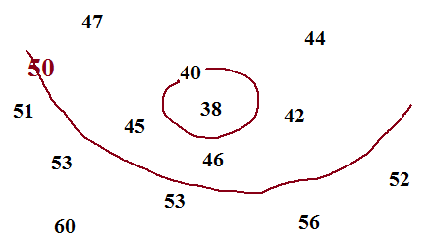
13. See if you can sketch in the 40º F and 50º F
isotherms on the figure at right.

14. Are clouds more likely to form when moist air COOLS or WARMS, when moist air RISES or SINKS?
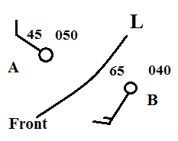
15. Weather conditions at two cities and a front are shown in the
figure at right. Would you expect the front to moving toward
CITY A or CITY B? Would this be a COLD or WARM
front.
The front will be rotating counterclockwise around the low
pressure center, so it's headed for City B. There's colder air
(45º F) behind the front (NW of the front). That's the air that
will be moving in, making this a cold front.

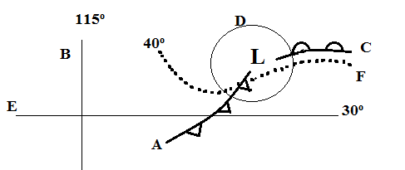
16. Find an example of each of the following
on the map drawn at right.

line of latitude___E (30º N)__
warm front ____C______
isotherm ____F_(40º F)_____
cold front ____A______
isobar____D______
line of longitude ___B (115º W)___
I meant to label the isobar 996 or something like that (i.e. a reasonable sea level pressure value)

