ATMO 170 Name_______________________________
Optional Assignment

1. The Gulf Stream is a warm ocean current that flows northward along the east coast of the US. The Gulf Stream is an example of energy transport by
a. conduction b. convection c. EM radiation d. latent heat

2. _______ and _______ occur during cloud formation. You would need to add energy to a material in order for _______ and _______ to occur. (fill in the blanks, each answer below should be used once)
a. condensation b. deposition c. evaporation d. sublimation

3. An object at room temperature that feels cold to the touch probably has
a. high specific heat b. high thermal conductivity c. high latent heat
d. low specific heat e. low thermal conductivity f. low latent heat

4. How many calories of energy would you need to add to 25 grams of water to warm the water 40º C. (show your work)

5. The atoms in a hot object have a lot of _______. It takes a lot of energy to warm or cool water because water has high _______. Copper has high _______. Cold air sinks because it has higher _______ than the surrounding air. Water vapor contains a lot of hidden ______. (each of the answers below should be used once)
a. kinetic energy b. density c. thermal conductivity d. latent heat e. specific heat
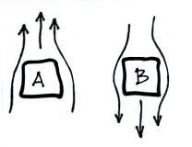
6. Convective air motions around two objects are shown at
right. Object _______ is probably colder than the
surrounding air. Energy is being transported from the
surrounding air to Object _______.

7. We are able to see the moon at night because it ABSORBS EMITS REFLECTS TRANSMITS visible light.

8. Rank the following in order from coldest ______
(bottom step) to warmest (top step) ______
a. 0º C b. 0º F c. 0º K ______
d. 100º C e. 100º F f. 100º K ______
______
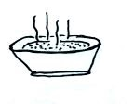
______

9. People often blow on a hot bowl of soup to try
to cool it so that they can eat it. What two
energy transport processes are causing the
most cooling?
10. Sunlight is _______. The EM radiation emitted by the earth is _______.
a. visible light b. about equal amount of visible, infrared, and ultraviolet light
c. mostly visible and infrared with a little ultraviolet light d. infrared light

11. Which of the following pairs of points on the wave of EM radiation below are exactly one wavelength apart?
a. A & B b. B & D c. A & C d. B & F e. A & E
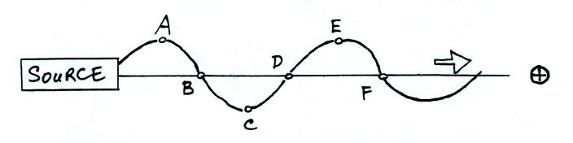

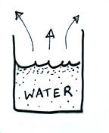
12. "The atmospheric window" refers to a range of wavelengths where the atmosphere EMITS ABSORBS TRANSMITS light and is found in the ULTRAVIOLET VISIBLE NEAR-IR FAR-IR part of the spectrum.

13. The water in the glass at right is evaporating. Would you expect
to find that the water is WARMER , COLDER, or the SAME
temperature as the surrounding air. Would energy be flowing from
the AIR to WATER or from the WATER to AIR.

14. Based on the information shown below the ground in ______________ is
in radiative equilibrium (fill in the blank with FIG A, FIG B, BOTH figures, or NEITHER figure). The temperature of the ground in Fig. A _____________ than(as) in Fig. B (fill in the blank with WARMER COLDER the SAME temperature).
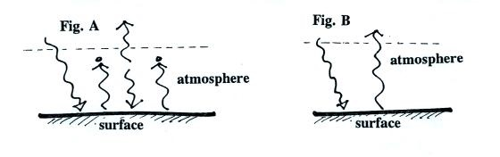

15. Which of the following has the highest energy and is potentially the most dangerous kind of EM radiation?
a. IR (10 µm) b. VISIBLE (0.4-0.7 µm) c. UV-A (0.32-0.4 µm) d. UV-B (0.28-0.32 µm) e. UV-C (0.1-0.28 µm)

