ATMO 170 Name___________Answers____________
Optional Assignment

1. The Gulf Stream is a warm ocean current that flows northward along the east coast of the US. The Gulf Stream is an example of energy transport by
a. conduction b. convection c. EM radiation d. latent heat
An ocean current is organized motion, that's why this is convection. If there were any phase changes mentioned in the question then you'd have to select latent heat transport.

2. ____a___ and ___b___ occur during cloud formation. You would need to add energy to a material in order for ___c___ and ___d___ to occur. (fill in the blanks, each answer below should be used once)
a. condensation b. deposition c. evaporation d. sublimation
Water vapor condenses to form liquid cloud droplets. Deposition of water vapor creates ice crystals (water droplets can also freeze).

3. An object at room temperature that feels cold to the touch probably has
a. high specific heat b. high thermal conductivity c. high latent heat
d. low specific heat e. low thermal conductivity f. low latent heat
The high thermal conductivity means heat is transported rapidly from your warm body. The perception of cold is really an indication that our body is quickly losing energy.

4. How many calories of energy would you need to add to 25 grams of water to warm the water 40º C. (show your work)

You can rearrange the equation ΔT = ΔE/( mass x specific heat) so that ΔE is by itself on the left side of the equal sign: ΔE = ΔT x specific heat x mass

The specific heat of water is 1 calorie/(gram ºC)

ΔE = 40º C x 1 cal/(g ºC) x 25 g = 1000 calories

5. The atoms in a hot object have a lot of ___a___. It takes a lot of energy to warm or cool water because water has high ___e___. Copper has high ___c___. Cold air sinks because it has higher ___b___ than the surrounding air. Water vapor contains a lot of hidden ___d__. (each of the answers below should be used once)
a. kinetic energy b. density c. thermal conductivity d. latent heat e. specific heat
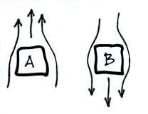
6. Convective air motions around two objects are shown at
right. Object ___B___ is probably colder than the
surrounding air. Energy is being transported from the
surrounding air to Object ___B___.
Cold air sinks. The sinking air around B is the clue that Object B is colder. It is cooling the air in contact with it and the air sinks (energy transport by convection). Energy naturally flows from hot to cold. In this case energy flows from the warmer air to colder Object B. Energy flows also from Object A to the cooler surrounding air.

7. We are able to see the moon at night because it ABSORBS EMITS REFLECTS TRANSMITS visible light. The moon isn't warm enough to be able to emit visible light.

8. Rank the following in order from coldest _100 C_
(bottom step) to warmest (top step) _100 F_
a. 0º C b. 0º F c. 0º K __0 C__
d. 100º C e. 100º F f. 100º K __0 F__
_100 K_
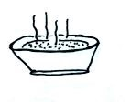
__0 K____

9. People often blow on a hot bowl of soup to try
to cool it so that they can eat it. What two
energy transport processes are causing the
most cooling?
Most everyone recognized that convection (forced convection) was involved. The second and probably more important process is latent heat energy transport (the hot soup is evaporating and taking energy from the soup and causing the soup to cool)

10. Sunlight is ___c____. The EM radiation emitted by the earth is ___d___.
a. visible light b. about equal amount of visible, infrared, and ultraviolet light
c. mostly visible and infrared with a little ultraviolet light d. infrared light

11. Which of the following pairs of points on the wave of EM radiation below are exactly one wavelength apart?
a. A & B b. B & D c. A & C d. B & F e. A & E
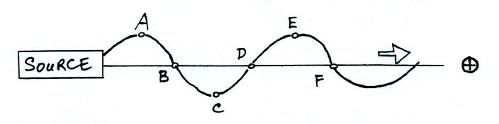

12. "The atmospheric window" refers to a range of wavelengths where the atmosphere EMITS ABSORBS TRANSMITS light and is found in the ULTRAVIOLET VISIBLE NEAR-IR FAR-IR part of the spectrum.
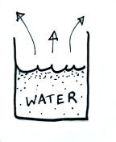
There is also a window in the visible portion of the spectrum but it is not
The atmospheric window.

13. The water in the glass at right is evaporating. Would you expect
to find that the water is WARMER , COLDER, or the SAME
temperature as the surrounding air. Would energy be flowing from
the AIR to WATER or from the WATER to AIR.
Without any evaporation the water would have the same temperature as the surrounding air. The evaporation takes energy from the water that is left behind and cools the water. Once the water finds itself cooler than the surrounding air energy will flow the warmer air to the cooler water.

14. Based on the information shown below the ground in ____BOTH_____ are
in radiative equilibrium (fill in the blank with FIG A, FIG B, BOTH figures, or NEITHER figure). The temperature of the ground in Fig. A ___warmer____ than(as) in Fig. B (fill in the blank with WARMER COLDER the SAME temperature).
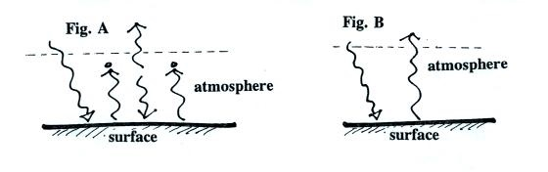

In Fig. A the ground is absorbing and emitting two units of radiant energy. The same is true of the atmosphere. Those everything in Fig. A is in balance.

In Fig. B the ground is absorbing and emitting a single unit of energy. The atmosphere isn't absorbing or emitting any energy.

The ground in Fig. A must be warmer to be able to emit 2 units of radiation compared to the 1 unit being emitted in Fig. B

15. Which of the following has the highest energy and is potentially the most dangerous kind of EM radiation?
a. IR (10 µm) b. VISIBLE (0.4-0.7 µm) c. UV-A (0.32-0.4 µm) d. UV-B (0.28-0.32 µm) e. UV-C (0.1-0.28 µm)
UV-C has the shortest wavelength and therefore the highest energy. All of the UV-C in sunlight is absorbed by the ozone layer, none of it makes it to the ground.

