ATMO170A1 Name__________Answers_____________
In-class Optional Assignment

1. A mixing ratio of 6 g/kg means there are 6 grams of ________water vapor__________
mixed in
with 1 kilogram of ____________air (dry air)__________.

2. If you know the air's temperature you can look up the value of the ___b___ in a table.
a. mixing ratio b. saturation mixing ratio c. relative humidity d. dew point
The saturation mixing ratio is the maximum amount of water vapor that can be found in air. It depends on the air's temperature so you would need to look up the value in a table. It tells nothing about how much water vapor is in the air.

3. Adding water vapor to the air will not increase the ___b___.
a. mixing ratio b. saturation mixing ratio c. relative humidity d. dew point
Adding water vapor to air will increase r, RH, and Td.

4. 90º F air can potentially hold ___c___ times as much water vapor as 45º F air (consult the table on p. 86 in the photocopied ClassNotes)
a. 2 b. 4 c. 5 d. 10
1 kg of 90º F air can hold up to 30 grams of water vapor. 45º F could, at most, hold 6 g/kg.

5. To calculate the relative humidity you need to know the ___a___ and the ___b___.
a. mixing ratio b. saturation mixing ratio c. air temperature d. dew point

RH = 100% x (r / r_{S})

6. The value of the _______ will tell you whether moist air is saturated or not.
a. mixing ratio b. saturation mixing ratio c. relative humidity d. dew point

7. Based on the data in the figure below, does the parcel of 70º F air have MORE LESS or the SAME amount of water vapor than(as) the 85º F air?

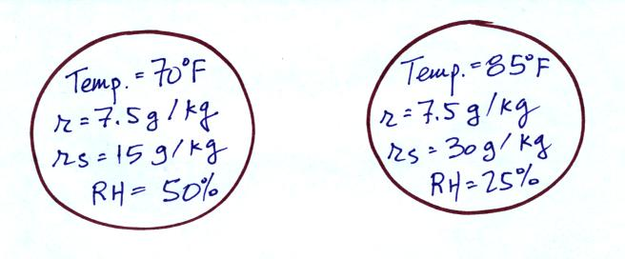

The mixing ratio tells you how much water vapor is actually in the air. The two volumes of air above have the same mixing ratio thus the same amount of water vapor.

8. Which two of the following have the same job, telling you how much water vapor is actually in the air?
a. mixing ratio b. saturation mixing ratio c. relative humidity d. dew point

