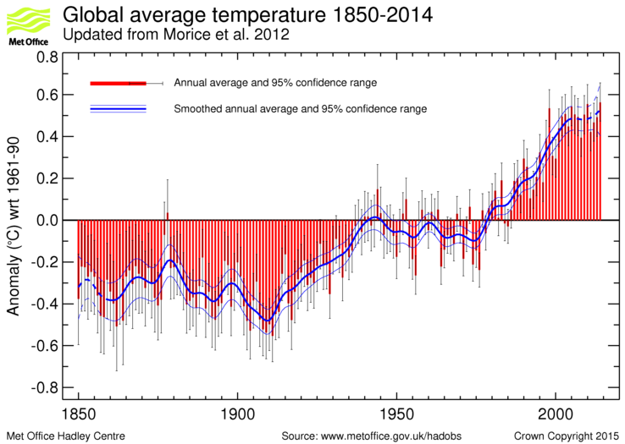
Notes / Questions about the recent temperature record
- The global average surface temperature is about 0.8° C warmer than in 1900.

- Is the recently measured warming of global average surface temperature mostly caused by increasing amounts of greenhouse gases in the atmosphere, or is it mostly part of a natural cycle, or is it a combination of the two?
  - Large warming from 1910 – 1940. This warming is too rapid and too large to be explained by the rather small increases in greenhouse gases that occurred during this period (inconsistent with conclusion that most of the warming since 1900 due to increased greenhouse gases).

  - A slight cooling trend occurred from about 1940 to the late 1970s even though greenhouse gas concentrations were increasing during this period (again inconsistent with conclusion that most of the recent warming caused by greenhouse gas increase). Cooling may have been caused by burning “dirty coal”.

  - Large warming from 1980 to about 2002. Also, the 19 warmest years on record (since 1850) have all occurred since 1990. This is consistent with the conclusion that recent global warming is mainly caused by increasing concentrations of greenhouse gases, but it is not proof.

  - Flattening of temperature trend since about 2002. This argues against greenhouse gas increases dominating temperature changes. However, the most recent decade is the warmest decade in the measured record and coincides with the highest concentrations of greenhouse gases.

