ATMO/ECE 489/589 Midterm Exam
March 8, 2011

Everyone should answer Question #1.
ATMO/ECE 489 students should then answer any 3 of the remaining 5 questions
ATMO/ECE 589 students should then answer any 4 of the remaining 5 questions
Allow about 15 minutes per question

1. Answer any three of the following questions.
(a) Briefly explain what makes the atmosphere a weak conductor of electricity. How and why does conductivity change with altitude? Do electrical currents travel through air in the same way that current travels through a piece of wire?
(b) It seems curious to me that electrical charge can be produced in the cold wet environment inside a thunderstorm. How is electrical charge created and distributed inside a thunderstorm?
(c) List and discuss some of the contributions Benjamin Franklin made to the study of lightning and atmospheric electricity
(d) Briefly describe how an electric field mill is able to measure static or slowly-varying electric fields.
(e) Briefly explain the difference between “fast” and “slow” electric field change antenna systems. Why do the signals from these antennas need to be integrated? What is the difference between passive and active integrators?

2. Thunderstorm fields just a few hundred meters above the ground are often much more intense than the fields at the ground. In the figure below the field at 200 m reaches a peak amplitude of about 25 kV/m just before a lightning discharge. By contrast corona discharge from trees, bushes, and other sharp objects on the ground added space to the air and limited the field at the ground to a value of about 8 kV/m.
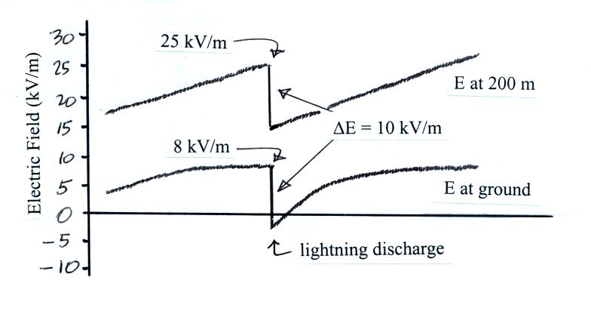

(a) Use the peak field values at the ground and aloft to estimate the volume space charge density in the layer between the ground and 200 m altitude. What is the polarity of this space charge? (note: a positive electric field value means E is pointing upward)

(b) Why is the value of the field change caused by the lightning discharge the same at the ground and at 200 m altitude (about 10 kV/m), even though the peak field values at the two altitudes are very different?

3. The electric field recorded under a small thunderstorm at one of the Kennedy Space Center field mill network sites is shown below. The first lightning discharge (CG) was observed striking the ground, the second discharge (IC) was apparently an intracloud discharge. Use this electric field data to estimate the Maxwell current density, J_{m}, at this site.

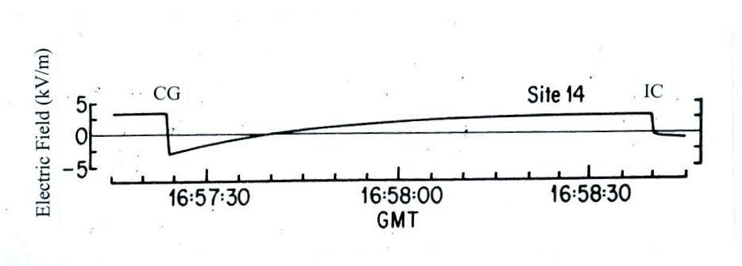
(Hint: the Maxwell current includes convection current, field-dependent conduction current, lightning current, and displacement current terms. You can assume that the convection current is negligible. If you estimate J_{m} in the interval between the two lightning discharges the lightning current contribution to J_{m} is zero. Take it from there and any additional assumptions that you make)
4. The majority of lightning discharges are intracloud lightning discharges and take place between the upper positive charge center and the main negative charge center. The lower positive charge centers may play an important role in the initiation of cloud-to-ground discharges.

Determine the strength and direction of the electric field at Point A, midway between the upper positive charge center and the negative charge center, and at Point B, midway between the main negative charge center and a lower positive charge center. (you can assume the 3 charge centers are small spherical concentrations of charge positioned directly above each other as shown in the figure below)
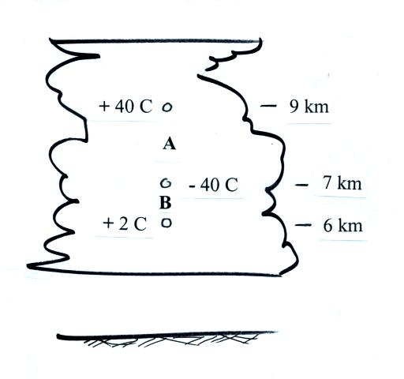

5. Given that the losses of small ions due to recombination and attachment to particles are equal, determine the steady state concentration of small ions, n, and the total particle concentration, Z, given the following conditions.

ion production rate (q): 10 ion pairs/(cm³ sec)
small ion recombination coefficient (α): 1 x 10⁻⁶ cm³/sec
small ion-particle attachment coefficient (β): 2 x 10⁻⁶ cm³/sec
loss due to recombination is equal to the loss due to attachment to particles

6. Air is flowing through the parallel-plate conductivity meter in the figure below at a rate of 1 m³/sec. A wire connected to the upper plate keeps it at a potential V. The current flowing to the top electrode, I, is plotted as a function of V in the graph below at right.

Assuming that the instrument has a capacitance of 300 pF, use the data shown above to estimate
(a) the volume charge density
(b) the air conductivity
(c) the small ion mobility (assume that all the small ions have the same mobility)

