ATMO/ECE 489/589 Spring 2015
Topics Summary for the Midterm Exam

Jan. 14,16 Overview of global electric circuit, typical fair weather conductivity, λ,
and electric field, Ez, values at the ground. Typical fair weather current density, Jz. Carnegie curve, global annual average flashing rate.

Jan. 21 Historical overview. Triboelectric charging, Van de Graaff generator, Wimshurst generator, demonstrations such as Franklin chimes and Volta hailstorm

Jan. 23 Contributions of Benjamin Franklin: power of points, sentry box & kite experiment, lightning rods.
Start review of electrostatics,
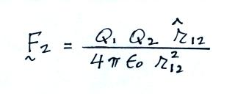
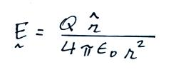
Coulomb's law
Electric Field

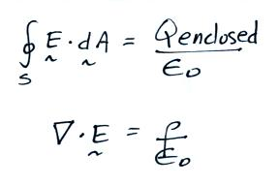

Gauss' Law (integral form)

Jan. 26 Gauss' Law (differential form)

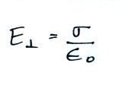

E field inside a conductor = 0
E field at the surface of a conductor
Electric field mill

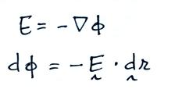
Jan. 28 Electrostatic potential

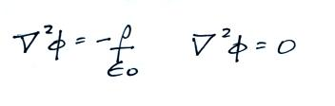
Poisson's Eqn.
Laplace's Eqn.

Flat plate E field (change) antennas
Fast and slow E field antennas (passive integrators)

Jan. 30 Active integrators for E field (change) antennas
Conducting sphere in a uniform E field
Feb. 2 Feynman - electric field enhancement near a sharp point, Atlas/Centaur incident
Balloon borne field mill
Estimates of volume space charge density from Ez profiles

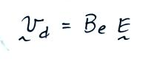
Feb. 4 Currents in the atmosphere, small ions

Electrical mobility, Be
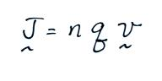
Current density
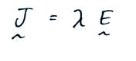
Ohm's law

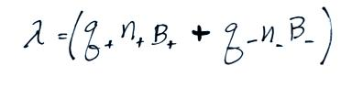
Conductivity

Resistivity and resistance
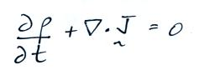
Continuity equation
(steady state → Jz constant with altitude)

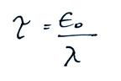
Discharge time or relaxation time

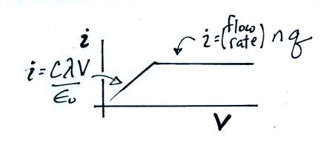

Feb. 6 Ion counters and conductivity meters

Feb. 9 Screening layers created by a conductivity discontinuity at the edge of a cloud
Measurements of conductivity, E field, and Jz as a function of altitude
Origin of atmospheric conductivity at different altitudes, over land and ocean
alpha, beta, gamma radiation from radioactive materials in the ground
alpha particles from Radon gas that diffuses from the soil
Decay series Th²³² (thoron series)
X Np²³⁷ (has all decayed away)
U²³⁸ (radon series)
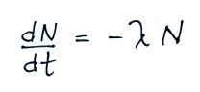
U²³⁵ (actinon series)

Radioactive decay
Example estimate of ionization rate from radon

Feb. 11 Cosmic rays dominant ionization source over the oceans at all altitudes
dominant over land above 1 km altitude

Formation of small ions
ionization of air molecules (free electrons, e⁻, N₂⁺ and O₂⁺)
e⁻ attaches to O₂ but not to N₂
water vapor molecules (and other gases) cluster around O₂⁻ , N₂⁺ , and O₂⁺
positive small ions have slightly lower mobility than negative small ions
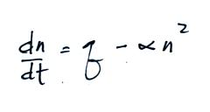
Ion balance equations
steady state solutions

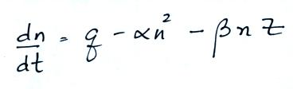
Feb. 13 Summary of electrical parameters
versus altitude handout
Ion-particle attachment – “large ions”

supplementary reading Microphysical structure of a cold cloud
cloud droplet and ice crystal nucleation
riming and graupel

Feb. 16 Typical distribution of electrical charge in a thunderstorm
Cloud electrification
Convective theory
Inductive process of electrification - depends on an existing electric field
Kelvin water dropper experiment
Non-inductive process (Reynolds, Gourley, Brook mechanism)
charge reversal temperature

Feb. 18 Reynolds, Brook, Gourley mechanism in more detail
Inverted polarity charge distribution in thunderstorms

Feb. 20 KSC field mill network & E field mill records from small and large storms
E field change measurements
Chi-squared function used to determine location (x,y,z) and magnitude of the
charge (ΔQ) neutralized by lightning flashes.

single charge and 2 arbitrary charge models
Typical ΔQ, charge heights and temperatures
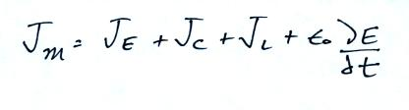
Feb. 23 Thunderstorm as a current source
Maxwell current
Direct measurements of Jm and estimates derived from E field measurements

