ATMO/ECE 489/589 Midterm Exam Review
March 9, 2015

Everyone should answer Question #1.
Then answer any 3 of the remaining 6 questions (please start each problem on a new sheet of paper) Allow about 10-15 minutes per question

1. (15 pts) Answer any three of the following questions
a. How do "fast" and "slow" electric field change antennas differ from an electric field mill. Why do the signals from these sensors need to be integrated? What are passive and active integrators?

1b. What is the basis for assuming that the current density J = J_{z} is constant with altitude?
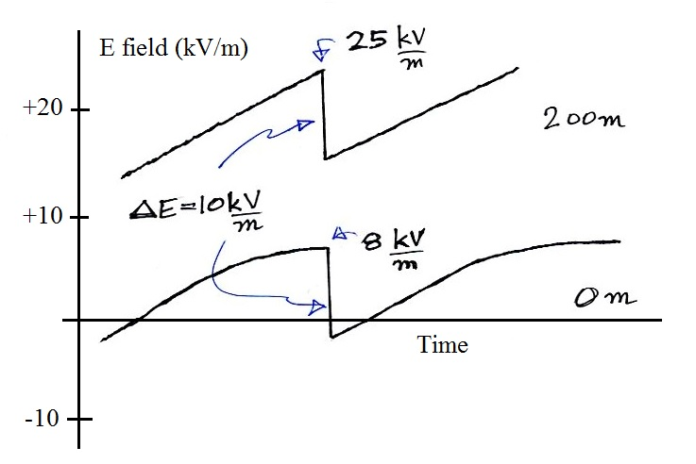
1c.

Note and explain the similarities and differences between the two E field signals above recorded under and active thunderstorm.

1d. Given the following data from the Summary of Electrical Parameters as a Function of Altitude handout determine the particulate concentration at which small ion loss due to recombination is equal to the loss by attachment to particles.
z = 0 km P = 1000 mb T = 288 K
q = 1.5 ip/cm³ sec α = 1.4 x 10⁻⁶ cm³/sec n = 1000 cm⁻³
β = 2 x 10⁻⁶ cm³/sec

1e. "Leyden Jars" were used in many of the early electrical experiments. What is a Leyden Jar?

2. (15 pts) Determine the steady state small ion concentration, n, for “clean” air (Z = 500 particles/cm³) and “dirty” air (Z = 5000 particles/cm³). You can assume
a small ion recombination coefficient α = 1.4 x 10⁻⁶ cm³/sec
a small ion to particle attachment coefficient β = 2 x 10⁻⁶ cm³/sec
an ion pair production rate q = 10 ip/(cm³ sec)

3. Starting with the continuity equation show that
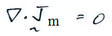

where
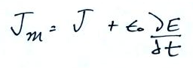

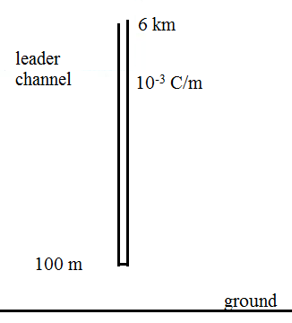

4. Compute the field at the ground directly below
a uniformly charged stepped leader channel extending
from an altitude of 6 km to a height of 100 m above
the ground. You can assume the linear charge density
on the leader channel is 10⁻³ C/m.

5. The earth's surface and the lower ionosphere resemble a spherical capacitor. The earth's surface is negatively charged and positive charge is found in the air between the ground and a level perhaps 50 km above the ground where the air can assumed to be a conductor. A steady current of about 2000 A flowing downward toward the ground would discharge the "capacitor" in a time of the order of 10 minutes. That does not occur, what keeps the earth - ionosphere spherical capacitor "charged up"?

