Answers with some explanation of how to get
the answers
ATMO 170
Humidity Variables Optional Assignment
1. Determine the following for Point A on the graph below (try to include the units)
air temperature___70 F____ mixing ratio__6 g/kg __ dew point ___45 F___
relative humidity___40 %_______ saturation mixing ratio__15 g/kg__
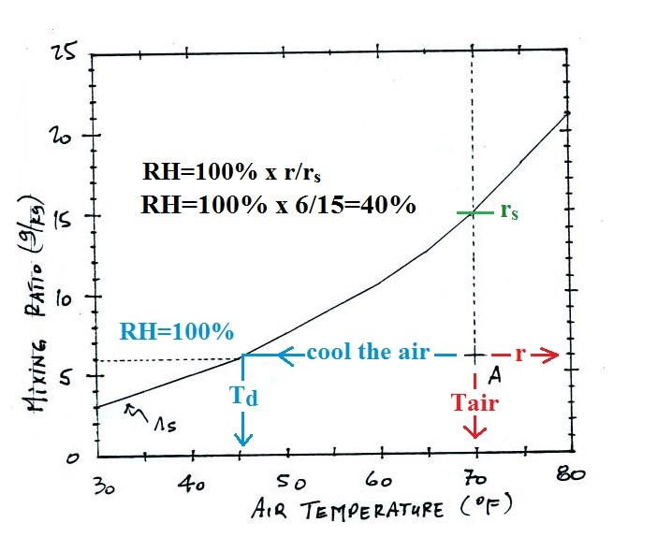

Use the table of saturation mixing ratio values at right below for Questions #2 and #3.
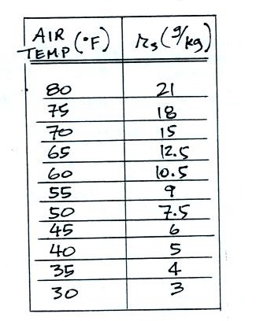
2a. If the air temperature is 70º F and the mixing ratio is 5 g/kg, what is the relative humidity? What is the dew point temperature?

First look up the saturation mixing ratio value (r_{s})
value for 70^{O} F air (it's 15 g/kg)

next RH = 100% x (r/r_{s}) = 100% x (5/15) = 33%

then cool the air until RH=100% that's the dew point (40 F)
T r r_{s} RH
70 5 15 33%
60 5 10.5 48%
50 5 7.5 67%
40 5 5 100%
2b. Calculate the relative humidity and the mixing ratio when the air temperature is 65º F and the dew point temperature is 50º F.

We first fill in a chart with what we know. We know when the 65 F air is cooled to 50 F the RH becomes 100%
T r r_{s} RH
65 12.5
60 10.5
55 9
50 7.5 100%

We didn't initially know the mixing ratio r. But we know that as we cool the air, r won't change (unless you cool the air below the dew point). Once we cool the air to 50, the dew point, the RH becomes 100%. So r must be equal to the value of r_{s} at 50 F. I.e. r = 7.5 g/kg.

Now we can go back and fill in the 1st line of the chart.
T r r_{s} RH
65 7.5 12.5 60% <----- RH = 100% x r/r_{s}
RH = 100% x 7.5/12.5

3. How many grams of water vapor are in 1 kg of saturated 70º F air? If you could somehow turn all that water vapor into water and then collect it, how many teaspoons of water would you end up with (1 tsp of water has a mass of 5 grams).
1 kg of 70 F air could hold up to 15 grams of water vapor (the saturation mixing ratio). Since there are 5 grams of water per teaspoon, you would end up with 3 tsp of water.

4. Assume that the actual amount of water vapor in the air remains constant during the day. Then
____ r____ and ____ Td ____ will remain the same during the day, ___ T ___ and ___ r_{s} ___ will probably be higher in the afternoon than in the morning, and ____ RH ____ will be higher in the morning than in the afternoon. (fill in each blank with T for air temperature, r_{s}, for saturation mixing ratio, r for mixing ratio, RH for relative humidity and Td for dew point temperature; each answer should be used once)

5. Based on the information at right would CITY A or CITY B City A City B
have the highest relative humidity, would CITY A or CITY B Tair = 80º F Tair = 70º F
have the highest actual amount of water vapor in the air? Td = 40º F Td = 50º F

For the highest RH we look for the city with the smallest difference between Tair and Td. For the highest actual amount of water vapor in the air we look for the city with the highest dew point.

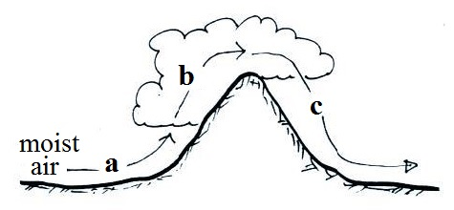
6. The mixing ratio, r, is increasing along Path _nowhere_ in the
figure at right. The relative humidity, RH, is increasing along
Path ___a____. Along Path ___b____ the mixing ratio is
decreasing and the relative humidity is decreasing along
Path ___c____. (fill in each blank with a, b, c as shown in the
figure or use d for nowhere; each answer should be used once)

7. Indicate whether the humidity variables r, r_{s}, RH, and Td will Increase, Decrease, or remain the Same
when moist air is warmed or cooled (consider both cooling and staying warmer than the dew point and cooling enough to drop below the dew point), and when moisture is added to or removed from the air.
