ATMO 336 – Sections 001 Name__________________________
Exam 1 – Spring 2016

Write all answers on the answer sheets on the last page of the exam.
Please mark your answers clearly. You will turn in both the question and answer sheets.

Multiple Choice Section (3.5 points each)
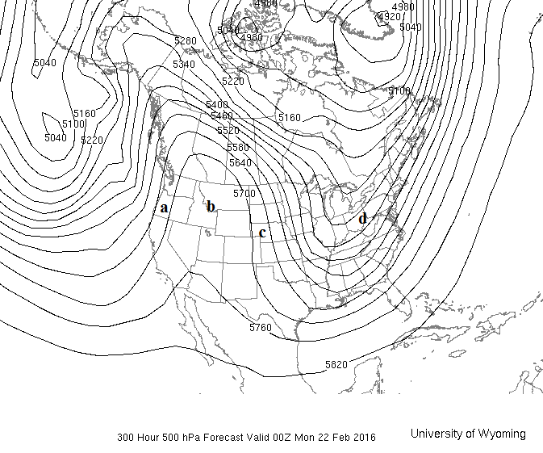
Use the 500 mb map above to answer questions 1 - 7
- Based on the time stamp found at the bottom of the map, what is the local time in Tucson?
  - 5 AM, Feb 21 (b) 5 PM, Feb 21 (c) 5 AM, Feb 22 (d) 5 PM, Feb 22

- At which marked point (a - d) do you expect temperature to be the most above average?

- Which marked point (a - d) is located within a trough?

- At which marked point, b or d, would you expect the best chance of precipitation? (Mark b or d)

- At which marked point is the 500 mb wind direction most near south to north?

- The climatological average 500 mb height for mid February in Tucson is about 5690 m. Based on this information and the map above, what forecast would you make for Tucson?
  - Sunny, above average temperature (c) Chance for rain, above average temperature
  - Sunny, below average temperature (d) Chance for rain, below average temperature

- The timestamp below the map shows this is a 300 hour (12.5 day) forecast. Based on the course material about numerical weather forecasting, how much confidence should be placed on the accuracy of the 500 mb height forecast shown in the map?
  - High confidence (b) Low confidence (c) No way to estimate confidence
- A local weather forecaster calls for an upper level ridge to “build” over the western United States over the next several days. What is most likely to occur in Tucson?
  - Rain followed by colder conditions (lower temperatures)
  - Rain followed by warmer conditions (higher temperatures)
  - Sunny and becoming colder
  - Sunny and becoming warmer

For Questions 9 and 10
Suppose we place some gas into a rigid container, then seal it tightly so that no gas can enter or leave the container. The container is rigid, so the size and shape (volume) of the container will not change. At first we measure the gas temperature to be 20° C and gas pressure to be 900 mb inside the container.

- If the gas inside the container is warmed up to a temperature of 30° C, how will the gas pressure inside change?
  - The pressure will be higher than 900 mb (c) The pressure will be lower than 900 mb
  - The pressure will not change (d) The answer cannot be determined

- How does the gas number density inside the container change as the gas inside is warmed?
  - The number density goes up (c) The number density goes down
  - The number density does not change (d) The answer cannot be determined

- Most of Earth’s atmosphere is composed of __________ .
  - oxygen (b) carbon dioxide (c) nitrogen (d) water vapor

- This gas is a toxic pollutant to humans in the lower troposphere. In the stratosphere this same gas protects us by absorbing ultraviolet radiation from the Sun.
  - Carbon Dioxide (c) Carbon Monoxide
  - Ozone (d) Sulfur Dioxide

- Humans can survive without assistance ___________ .
  - in the lower part of the troposphere only
  - throughout the entire troposphere, but not the stratosphere
  - throughout the entire troposphere, and in the lower part of the stratosphere
  - throughout the entire troposphere and stratosphere

- Which of the following typically increases in value as you move upward from the ground to the top of the troposphere?
(a) air pressure (c) air density
(b) air temperature (d) none of the choices given

- Winds on Earth are caused by ______ .
  - the rotation of the Earth
  - the frictional force between the air and the ground surface
  - horizontal changes in air pressure
  - phase changes of water

- For Tucson, the sea level pressure that is plotted on surface weather maps is ________ the air pressure measured with a barometer.
  - always higher than (c) sometimes higher and sometimes lower than
  - always lower than (d) always the same as

- Which typically takes more time (based on the amount of time in the air)?
  - A commercial flight from San Francisco to New York
  - A commercial flight from New York to San Francisco
  - On average, both flights should take the same amount of time.
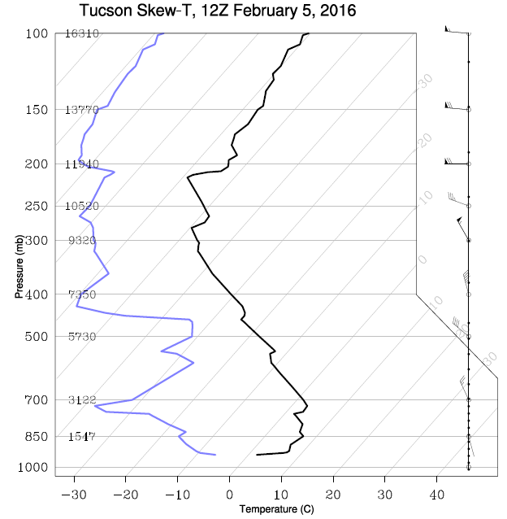

Use the Skew-T diagram above to help answer questions 18 - 20
- What is the air temperature at the altitude where the air pressure is 500 mb?
  - -60° C (b) -31° C (c) -18° C (d) 3° C

- The proper way to specify the wind at the altitude where the air pressure is 500 mb is _______ .
  - southeast at 200 knots (c) southeast at 40 knots
  - northwest at 200 knots (d) northwest at 40 knots

- Based on the Skew-T shown above, what is the approximate air temperature in the tropopause?
  - 0˚ C (b) -20˚ C (c) -40˚ C (d) -60˚ C

- For water vapor to condense, energy must be ________ by the water. Thus, condensation results in __________ of the surrounding environment.
  - released ; cooling (c) absorbed ; cooling
(b) released ; warming (d) absorbed ; warming

- Near the surface of the Earth, which of the following is true most of the time?
- the rate of condensation is faster than the rate of evaporation
- the rate of evaporation is faster than the rate of condensation
- the rate of evaporation equals the rate of condensation

Instructions for Short Answer Questions – 10 Points Each
For each numbered question (1-3), you must select and answer one of the lettered choices (a) or (b). Write your answers on the lines provided for the short answer section. Make sure you answer all parts of each question you select. Your answers should be short and to the point. Points will be deducted for incorrect or unnecessary statements in your answer, even if the correct answer is found somewhere. Please write neatly. If I cannot read your answer, you will not be awarded any points.

- Select (a) or (b)
  - Some people say that roughly half of the Earth’s atmosphere is above 500 mb and roughly half of the atmosphere is below 500 mb. In what sense is roughly half the atmosphere above 500 mb and roughly half of the atmosphere below 500 mb? Explain how this is possible given that the 500 mb height is at an altitude of about 5 km, while the entire atmosphere extends up to 500 km altitude. The ratio of the 500 mb height to the total height of the atmosphere is about 5/500 (or 1/100), not 1/2.

  - At ground level, the air pressure measured with a barometer is 1000 mb. The barometer is lifted upward by a weather balloon. When the balloon reaches 2 km above the ground, the measured air pressure is 800 mb. Explain why the air pressure decreased. After the balloon goes up another 2 km (now 4 km above the surface), do you expect the measured air pressure 4 km above the surface to be exactly 600 mb, lower than 600 mb, or higher than 600 mb? Explain the reason for your answer.

- Select (a) or (b)
  - Suppose a very warm air mass covers the entire Eastern half of the continental United States and a very cold air mass covers the entire western half of the United States. Where would you expect to find the strongest winds at 500 mb … above the middle of the cold air mass, above the middle of the warm air mass or above the boundary between the warm and cold air masses? Explain why. Determine the 500 mb wind direction above the boundary between the two air masses. You should include all the important forces that act on the air in your answer.

  - A hurricane has an area of low sea level pressure at its center. On a surface weather map a large L would mark the center of the hurricane and it would be surrounded by circular isobars. A strong hurricane with wind speeds over 150 mph (miles per hour) will have a central sea level pressure of 920 mb or lower. The average sea level pressure is 1013 mb. Explain why the wind speed generated by a hurricane gets stronger as the sea level pressure at its center becomes lower. Describe the surface wind flow pattern surrounding the center of a hurricane in the Northern Hemisphere. What role does this surface wind pattern play in the development of the heavy rain produced by hurricanes.

- Select (a) or (b)
  - Formation of downdrafts. As rain falls from a cloud toward the ground, the raindrops pass though air that is subsaturated with respect to water vapor, i.e., the vapor pressure is less than the saturation vapor pressure. Under these conditions the raindrops start to evaporate since the rate of evaporation is faster than the rate of condensation. Describe the energy exchange between the raindrops that are evaporating and the air surrounding the raindrops. How will this act to change the temperature of the air surrounding the raindrops? Assuming this change in air temperature happens at constant pressure, will this cause the air to expand (increase its volume) or contract (decrease its volume)? Explain why this change in volume will tend to make the air that contains evaporating raindrops sink downward (accelerate toward the ground).

  - Water boils when the saturation vapor pressure of the water equals the surrounding air pressure. Explain why water will boil at a lower temperature on top of a 12,000 foot (3650 meter) mountain. Suppose you are camping at an altitude of 12,000 feet and cooking food with boiling water. What adjustments must you make compared to cooking with boiling water at lower altitude? Which of these may help to increase the temperature of the boiling water: (i) simply “turn up the heat” on your camping stove or (ii) put a heavy lid on top of the pot of boiling water? Briefly explain your answer.
ATMO 336 Name _________________________
Exam 1 – Multiple choice answer sheet

1. a b c d 12. a b c d
2. a b c d 13. a b c d
3. a b c d 14. a b c d
4. a b c d 15. a b c d
5. a b c d 16. a b c d
6. a b c d 17. a b c d
7. a b c d 18. a b c d
8. a b c d 19. a b c d
9. a b c d 20. a b c d
10. a b c d 21. a b c d
11. a b c d 22. a b c d
Use other side for short answers. Use the lines below if you need more space.
________________________________________________________________________________________________________________________________________________________________________________________________________________________________________________________________________________________________________________________________________________________________________________________________________________________________________________________________________________________________________________________________________________________________________________________________________________________________________________________________________________________________________________________________________________________________________________________________________________________

