ATMO/ECE 489/589 Spring 2017
Homework #5 due Tue., Mar. 28

1. (20 pts) The first stroke from a severe (worst case) lightning current waveform used in lightning testing is shown below (a test waveform would normally also include several subsequent strokes).
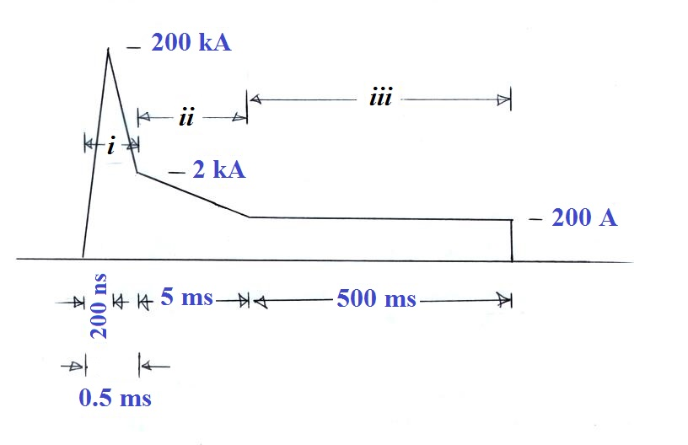

(a) Determine the peak dI/dt value (you can ignore the discontinuity at the end of the waveform)
(b) Determine the charge transferred in intervals (i), (ii), and (iii). Which interval transfers the most charge?
(c) Compute the “action integral” for intervals (i), (ii), and (iii). Which interval makes the largest contribution to the action integral.
(d) Determine the total energy delivered by the entire waveform to a resistive load of 10 ohms.

