ATMO/ECE 489/589 Spring 2017
Homework #6 Pt. 1 due Thu., Apr. 6, 2017

1. (15 pts) The figures below show 28 simultaneous measurements of peak I and peak E (left figure) and peak dI/dt and peak dE/dt (right) that were part of an experiment* to test the validity of the transmission line lightning return stroke current model.
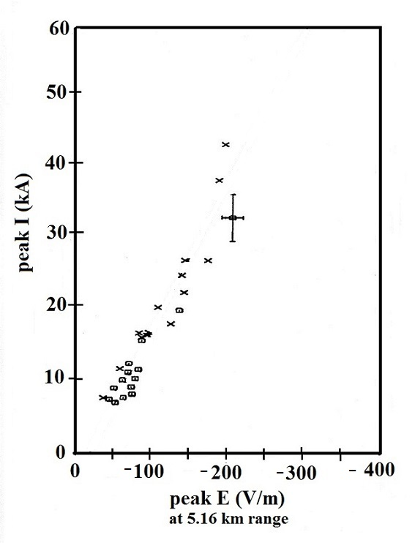
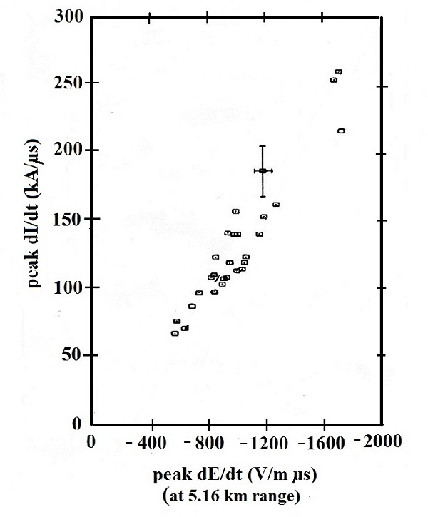

The I and dI/dt values were measured in subsequent return strokes triggered at the Kennedy Space Center in the summer of 1987. The E and dE/dt field measurements were made at a location 5.16 km away. The fact that the points appear to be linearly distributed seems to confirm the transmission line model prediction of a direct proportionality between Ipk and Epk [ or (di/dt)pk and (dE/dt)pk ].

1a. Fit a straight line, that is constrained to pass through the origin, to both sets of data. I.e. determine the equation of the line y = ax rather than y = ax + b that best fits both data sets.

1b. Determine the apparent upward return stroke velocities corresponding to each straight line fit. Are the velocities for the E & I and the dE/dt & dI/dt data sets the same? Should they be?

* from: J.C. Willett, J.C. Bailey, V.P. Idone, A. Eybert-Berard, and L. Barrett, "Submicrosecond Intercomparison of Radiation Fields and Currents in Triggered Lightning Return Strokes Based on the Transmission-Line Model," J. Geophy. Res., 94, 13275-13286, 1989.

You'll find a link to an Excel file containing all of the I, E, dI/dt & dE/dt data on the class webpage.
The usual method for fitting an equation to a collection of data points is to minimize the sum of the squares of the differences between measured and calculated values. I.e.
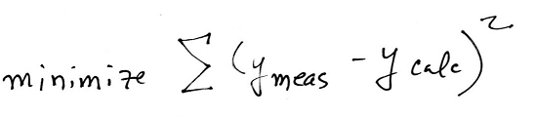

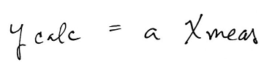
In our case

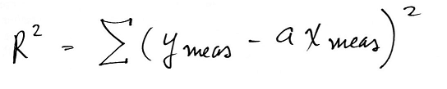
So we want to minimize

The usual procedure for finding a minimum is to take the derivative and set the result equal to zero.
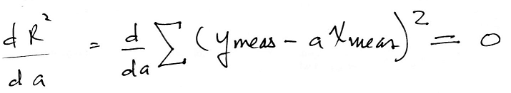

You can probably "take it from here." Take the derivative, set the result equal to zero and solve for a.

